Spatio-temporal patterns in the postglacial flooding of the Great Barrier Reef shelf, Australia.

Gustavo Hinestrosa

Jody M. Webster

Robin J. Beaman

# Abstract

The shelf of the Great Barrier Reef (GBR) was progressively marine flooded from the last glaciation (ca 20 ka BP) until the last sea-level highstand (ca. 6 ka BP), affecting the depositional evolution of the GBR and associated deposits. However, in terms of its physiographic variables, and at a spatio-temporal scale relevant for the postglacial evolution of the GBR, this process has not been fully characterized. For this study, we used a bathymetric model of the entire shelf, and a shelf margin subset, sliced into 33 latitudinal zones. Postglacial marine flooding was simulated and flooded area (km2), flooding magnitude (km2 per sea-level increment), flooding rate (km2 . ky-1) and coastline length (km) were estimated for each zone, from 130 m to 0 m below present sea level, in 5 m steps, representing the period from 20 ka to 6 ka BP. Our results show that the postglacial marine flooding did not occur uniformly and that some sub-regions (e.g. the southern-central GBR) had early and rapid flooding. Coastal complexity increased in the mid-postglacial, reaching maximum values at around 9 ka BP. This reflects a coastal landscape evolving from a linear, laterally connected coast to a complex coast dominated by estuaries and lagoons, partly returning to its initial linearity during the highstand. Flooding trends and geological evidence make two depositional relationships apparent. Firstly, the timing and magnitude of the off-shelf sediment flux appears linked to the presence and orientation of a shelf-edge rim, and to the extension and morphology of the evolving drainage network. Secondly, the periods of shelf-edge reef development and demise seem to respond to the remobilisation, trapping or redirection of fine sediments. We propose a sedimentation model for the shelf margin and the slope driven by the interplay of sea-level rise and shelf physiography, where two processes play a fundamental role: (1) the cross-shelf sediment transport related to coastline retreat under rising sea levels, and (2) the effectiveness of transient embayments in redirecting or trapping sediments. The quantifications provided in this study may have implications in the estimation of Pleistocene carbonate budgets and the atmospheric carbon cycle, as well as for past human migrations.

# Introduction

The wide (50 to 200 km) continental shelf of northeastern Australia has been repeatedly subaerially exposed and flooded during the late Quaternary (Hopley et al., 2007). These sea-level cycles have significantly impacted the depositional architecture of the world’s largest extant mixed carbonate/siliciclastic passive margin, and the location of the Great Barrier Reef (Maxwell and Swinchatt, 1970; Mount, 1984; Davies and McKenzie, 1993). The overarching process influencing reef and sediment deposition was the postglacial sea-level rise; particularly the rate and amplitude of this transgression and the way it was influenced by shelf physiography.

At least eight episodes of shallow-water reef accretion have occurred on the Great Barrier Reef (GBR) shelf in the last 600 ky (Webster and Davies, 2003; Humblet and Webster, 2017). During the Last Glacial Maximum (LGM, Clark et al., 2009) and the subsequent postglacial period (last 30 ky) conditions were conducive to the production of shallow-water carbonates on the shelf (Hopley et al., 2007) and the shelf margin (Beaman et al., 2008; Webster et al., 2011; Hinestrosa et al., 2016). Shallow shelf bathymetry, suitable substrate availability, and optimal climatic and oceanographic conditions for reef accretion were necessarily widespread along the GBR shelf (Davies, 1988; Davies and Peerdeman, 1998; Petherick et al., 2013; Reeves et al., 2013). The influence of terrigenous sediments has also been a key depositional control on on reef development on this shelf (Larcombe and Woolfe, 1999; Fielding et al., 2003; Page and Dickens, 2005; Ryan et al., 2007; Bostock et al., 2009; Hinestrosa et al., 2016).

The relationship between sea level and shelf physiography has been proposed to a lesser or greater extent as the main control on the deposition of coastal (Harris et al., 1990; Woolfe et al., 1998b; Lambeck and Woolfe, 2000), mid-shelf (Harris et al., 1990; Woolfe and Larcombe, 1998; Woolfe et al., 1998a), shelf margin (Hinestrosa et al., 2016), and slope deposits (Page and Dickens, 2005; Francis et al., 2007; Puga-Bernabéu et al., 2014). The postglacial flooding of the GBR shelf has been studied more often from a sedimentologic, stratigraphic and bio-geological point of view (XXXADD Johnson, Davies 1989, Davies, XXXX HopleyXXXX, Dunbar, Woolfe, HopleyXXX to name a few) than from a *strictly* physiographic one. Nonetheless, early work by Maxwell (1968) provided a description of the geomorphology of the GBR shelf as a whole. Of note is also Harris et al., 1990, whose analysis went beyond the sedimentological/stratigraphic characterisation by linking the depositional history with sea-level fluctuations and the palaeo-coastal morphology. In particular, they highlighted the transition from a linear during the LGM to an estuarine coast during the mid-transgression.

Despite these important advances , the quantification of physiographic variables (e.g. coastal complexity, flooded areas, etc.) in relation to the last postglacial has been limited, often restricted to palaeo-geographic maps of shelf flooding in support of geological interpretations (e.g. Page and Dickens, 2005; Hopley et al., 2007). These early pioneering attempts were undertaken in the absence of more recent high-resolution digital elevation models (DEMs) of the sea floor, and recently acquired geological (e.g. dredges, shelf margin cores, radiometric dates) and geophysical data (e.g. bathymetry, backscatter, seismic surveys) (Bostock et al., 2009; Beaman, 2010; Abbey et al., 2011; Webster et al., 2011; Hinestrosa et al., 2016).

Other works have quantified the morphology of the Australian shelf (Porter-Smith and McKinlay, 2012) and of the deeper marine areas (Porter-Smith et al., 2012). Harrison et al. (1983) investigated the Australian hypsography at a continental-scale, but was not specific to the northeastern Australia margin. Work by Brooke et al. (2017) demonstrated the value of palaeo-sea-level reconstructions in framing the different palaeo-shoreline features occurring on the Australian shelf during the Late Quaternary (0-128 ka). However, none of these contributions was specific to the spatio-temporal flooding patterns on the GBR shelf.

Because of their deeper bathymetry, the shelf-edge reefs of the GBR are particularly useful to investigate the LGM and subsequent deglaciation (Woodroffe and Webster, 2014). The shelf-edge reefs have been surveyed with multibeam bathymetry and dense networks of seismic profiles in several locations (Beaman et al., 2008; Abbey et al., 2011; Hinestrosa et al., 2016), and were drilled in three areas by the Integrated Ocean Drilling Project, Expedition 325 (IODP Exp. 325, (Webster et al., 2011). The cores from that expedition revealed coralgal deposits ranging in age from 30 ka BP (MIS-3) to ca. 10 ka BP (MIS-1) (Webster et al., 2011; Gischler et al., 2013; Felis et al., 2014). Seismic, stratigraphic and bathymetric analysis suggest a strong influence of the local substrate and of the shelf physiography in connection with the sea-level fluctuations (Hinestrosa et al., 2014; Hinestrosa et al., 2016). However, even with these new constraints on age, architecture and development, the fundamental causes of the variations in reef accretion and demise along the shelf margin have not been fully characterised.

The new datasets available for this margin includes the most comprehensive bathymetric model for the GBR shelf (Beaman, 2010), permitting a detailed reconstruction of the postglacial shelf flooding. Quantification of the postglacial flooding can provide the physiographic and geomorphic framework needed for understanding the spatio-temporal evolution of the GBR shelf deposits and coastal system, and the main depositional mechanisms operating on mixed siliciclastic-carbonate margins. Moreover, it provides additional spatial and volumetric constraints to the marine geochemical cycles related to shallow water carbonate production (Patterson and Walter, 1994; Andersson and Mackenzie, 2004; Rees et al., 2007; Heap et al., 2009), with implications to the wider postglacial carbon cycle (Ciais et al., 2013). The shelf-flooding patterns also constrain the ancient migration paths and exposed landscape used by indigenous Australians (Mulvaney, 1975; Beaton, 1985).

This paper provides a new reconstruction of the spatio-temporal patterns of shelf flooding and coastline morphology for the entire GBR over the past 20 ka. The specific objectives of this study are to quantify: [1] the marine flooded area during the postglacial flooding; [2] the pace (in terms of shelf marine cover and flooding rate) at which the flooding occurred; [3] the coastline evolution; and [4] to identify and discuss the main spatio-temporal trends in the context of shelf-edge reef development and slope deposition.

# Regional setting

The GBR shelf is located on the passive margin of northeastern Australia (Figure 1) a region of low tectonic activity (Hopley et al., 2007) and low subsidence rates (DiCaprio et al., 2010). The continental platform of the GBR stretches over 2300 km from the Torres Strait and Cape York in the north, to the Capricorn-Bunker Group of reefs, over 15° of latitude. Its width varies from less than 50 km in the north to more than 250 km in the central GBR, where the Capricorn Channel splits the shelf with a wide, southward drainage network, subparallel to the shelf. It narrows again south of the Capricorn Channel, to about 80 km in the vicinity of the Capricorn-Bunker Group of reefs. Some 3000 reefs have developed along this shelf, affecting sediment distribution and composition (Harris et al., 1990; Heap et al., 1999; Heap et al., 2002) and shelf circulation (Wolanski et al., 1988; Wolanski, 1994; King and Wolanski, 1996; Luick et al., 2007). On the inner-shelf, terrigenous sediment wedges have been deposited during highstands (Larcombe and Carter, 1998), sourced mainly from coastal rivers. These terrigenous deposits transition into inter-reefal carbonate sediments and reef structures on the mid- and outer-shelf (Scoffin and Tudhope, 1985; Harris et al., 1990).

The mid- and outer-shelf are dominated by carbonate mud and sand, and the prominent reef structures are interrupted by inter-reef channels connecting to the upper continental slope. In the north, these channels connect to the heads of the numerous canyons incising the continental slope (Puga-Bernabéu et al., 2013). Some of these channels are remainders of lowstand fluvial deposition and are filled with terrigenous sediments (Johnson et al., 1982; Fielding et al., 2003; Ryan et al., 2007). At the shelf margin, extensive drowned lowstand and early transgressive reefs have developed (Beaman et al., 2008; Abbey et al., 2011; Hinestrosa et al., 2014; Hinestrosa et al., 2016). At the foot of these shelf-edge reefs, on the upper-slope are mixed siliciclastic-carbonate deposits (Page and Dickens, 2005; Bostock et al., 2009; Harper et al., 2015) thinning towards the adjacent deep basin.

The GBR shelf is influenced by the circulation of the South Equatorial Current and its northward and southward branches along the GBR shelf: the Hiri Current and East Australia Current. The latter impinges obliquely on the northern-central GBR (Ridgway and Dunn, 2003) affecting intra-shelf circulation (Andrews and Clegg, 1989; Brinkman et al., 2002). The GBR is also affected by mesotidal currents (Wolanski, 1994; Hopley, 2006), which enhance intra-shelf circulation and affect morphology (Harris et al., 2005; Hopley, 2006). Cyclone-driven surface currents and waves transport sediment predominantly northward (Lambeck and Woolfe, 2000; Larcombe and Carter, 2004; Harris and Heap, 2009).

# Dataset and methods

## Marine-flooded areas

The ‘gbr100’ bathymetric model used in this study is 0.001° (ca. 100 m) resolution grid covering the GBR shelf from Fraser Island in the south to Cape York in the north (Figure 1; Beaman, 2010). This bathymetric grid was sliced into 33 latitudinal zones, at 50 km intervals.

Flooding was simulated, for each of the zones, with predefined sea-level inundation values ranging from 130 to 0 m at 5 m step intervals. These values are consistent with published relative sea-level curves (e.g. Lambeck and Chappell, 2001; Lambeck et al., 2014) . For each sea-level increment within each latitudinal zone, the polygons representing the marine-flooded areas were extracted and their surface area calculated in square kilometers. These area values were transformed into relative values, with the present-day, highstand area representing 100%. The increase in marine-flooded area with each sea-level increment was also calculated, and we refer to this value as the ‘flooding magnitude’ in km2 per sea-level increment (km2 . increment-1) with the increments defined as 5 m sea-level steps *from* 130 mbsl *to* 0 mbsl or the present sea level. The flooded area per unit of time was also estimated and we refer to it as ‘flooding rate’ in km2 per thousand years (km2 . ky-1).

The coastline length was used as a proxy measure of coastal complexity. Higher coastal complexity means more distance along the coastline compared to a less complex, linear coast for the same sector of the shelf, with the extra distance due to the occurrence of estuaries, islands, reefs and other coastal features. The coastline length for each sea-level increment was extracted from the flooding polygons for each of the latitudinal zones and these values were normalized to the LGM value (length at the 130 m mark) and also normalized to the maxima. Alternative methods are available to assess coastal complexity, namely fractal analysis (Mandelbrot, 1967) and the angle measure technique (Andrle, 1994; Bartley et al., 2001). However, considering the fixed width of the latitudinal zones, the coastline length as presented here constituted a simple but robust proxy. The reader should be aware of the so-called *coastline paradox*, for which the coastline length is dependent on the scale of measurement, as pointed out by Mandelbrot (1967). Hence, the seemingly high values of coastline length seen in this study are consistent with the high resolution of the bathymetry model used.

Throughout the descriptions and interpretations we employ the term ‘shelf margin’ to refer to the areas contiguous to the shelf break or shelf edge. We also defined a shelf margin bathymetric subset, which contains the bathymetric values *from* the shallowest outer-shelf reefs, *to* the 130 m isobath, where the shelf margin meets the upper slope. To refer to geomorphic features in this area, we employ the term ‘shelf-edge’ as an adjective, e.g. shelf-edge reefs. This also allows us to keep our nomenclature consistent with past studies on these shelf-edge reefs (Beaman et al., 2008; Hinestrosa et al., 2014; Webster et al., 2018).

The marine-flooding properties (relative flooding, flooding magnitude, flooding rate and coastline length) were also estimated for the shelf margin subset of the bathymetric model (Figure 2-A). This polygon was also split into the similar 33 latitudinal zones for the calculation of flooding and coastal complexity parameters.

## General assumptions and uncertainty

We have assumed that the present-day bathymetry of the GBR shelf approximates the LGM substrate depths. In reality, in reef locations and infilled river channels (drowned estuaries), the original substrate is substantially lower (up to ca 30 m) due to the post-glacial sediments and reef accumulation (Larcombe and Carter, 1998; Heap et al., 2002; Webster and Davies, 2003; Montaggioni, 2005; Hopley et al., 2007; Dechnik et al., 2015; Hinestrosa et al., 2016). If well these areas represent a significant portion of the total shelf surface (Harris et al., 2012), most areas of the shelf have postglacial sediment thicknesses of only a couple of meters or less (Searle and Harvey, 1982; Johnson and Searle, 1984; Harris et al., 1990).

We used the original bathymetric surface provided in Beaman, 2010 for our estimations. However, we performed a sensitivity by lowering this surface by 10 m, which confirmed that, overall, the flooding trends remain similar (see supplementary data). Thus, for a regional GBR-scale analysis, our results are an approximation (±10 m in bathymetry) for postglacial flooding.

We used an approximate geological time scale (in ka BP) based on the relative sea-level curve from Lambeck et al., 2014 (Figure 3-A). This past sea-level to geological age conversion is a reasonable approximation given the regional scope of our study and the millennial temporal resolution of our interpretations. However, to acknowledge relative sea level uncertainties (hence, geological time conversions) we have plotted the minimum and maximum sea level interpreted from GBR samples (Yokoyama et al., 2018; figure 3-A).

The reader should be also aware of hydroisostatic effects, which –due to the larger temporal and spatial scales involved­– have been ignored in our calculations. However, it has been estimated that hydro-isostasy or water loading has caused tilting of the shelf across the GBR of between +3 m along the present-day coast and −2 m on the upper continental slope (Chappell et al., 1982; Lambeck and Nakada, 1990; Yokoyama et al., 2006).

We acknowledge possible age bias in the core samples of the slope of the GBR shelf. In borehole ODP 820 (Dunbar et al., 2000), more recent pollen radiometric ages have confirmed a radiometric age bias (Moss et al., 2017), possibly introduced by the diagenesis of foraminifera tests. Most of the bias in those samples remain within our range of uncertainty (ca 1 ky), but a more significant deviation can be identified for ages older than ca 15 ka BP. Future work could help quantify the uncertainty and correct the ages in these cores.

In the color maps, results near the opening of the Capricorn Channel (ca. 22.5° S) are biased. This is due to the orientation of the shelf in the channel compared to the rest of the GBR. In this case, the marine flooding charts shown in Figure 3 are more useful for the assessment of the flooding and coastal patterns of the Capricorn Channel, as this area represents the merging of many latitudinal zones into 5 sub-regions.

# Results

In Figure 3, multiple latitudinal zones are grouped into curves, showing trends for the whole GBR and for five sub-regions: the northern GBR, the northern-central GBR, the southern-central GBR, the Capricorn Channel and the southern GBR (Figure 1). These graphs show the flooding patterns through geological time, which facilitates the comparison with the timing of depositional events in the region (Figure 3-I). Results are also presented as color maps (Figure 5 and Figure 6).

## Major spatio-temporal flooding patterns

Several patterns are distinguished in the curves (Figure 3) and color maps (Figure 5 and Figure 6) The GBR shelf has been progressively flooded since the LGM, with half of the shelf area already submerged when sea level approached 40 m below the present level (ca. 10 ka BP). The different GBR sub-regions, however, exhibit considerable variations in the timing, magnitude and rate of flooding. The southern-central GBR, including the Capricorn Channel as a whole, shows an earlier flooding than the northern and southern sub-regions.

The flooding magnitude and rate curves for the GBR shelf as a whole have a strong imprint of the trends of the northern, southern, and southern-central sub-regions. Two periods of rapid addition of flooded area are seen at 65 m (ca 12–13 ka BP) and 25 m (ca. 9 ka BP), with moderate and large values of added flooded area, respectively (Figure 3-C, -D). However, the curves for the individual sub-regions reveal contrasting patterns: the southern-central GBR saw an earlier increase in the flooding magnitude and rate when sea level reached the 70–80 m mark (ca. 13 to 14 ka BP), sustaining these high values until the highstand. In contrast, the narrower shelf at the northern and southern GBR did not see an increase the flooding magnitude and rate until sea level surpassed the 40 m mark (after 11 ka BP).

At the shelf margin, due to the deeper bathymetry, local flooding occurred earlier, with 50% of the areas at the shelf margin flooded when sea level reached 80–90 m (ca. 14 ka BP). The northern-central GBR and southern-central GBR sub-regions show patterns analogous to that of the GBR shelf margin as a whole. The northern and southern GBR shelf margin sub-regions flooded later, and exhibit flooding magnitude maxima that are mainly out of phase with both the whole and the central GBR shelf margin flooding curves (Figure 3-B, -C, -D vs. Figure 3-F, -G, -H).

In general, the coastline length increased steadily since the LGM along the entire GBR (Figure 3-E), reaching a maximum of ca. 45,000 km during the mid-postglacial, after 10 ka (ca 40 m) and then decreased to a lower value of ca. 15,000 km as the sea level approached highstand at 6 ka. magnitude and rate a The southern-central GBR reached the maximal coastline length earlier than the rest of the GBR.

The color maps in Figure 5 highlight the latitudinal variations already suggested by the curves of the sub-regions in Figure 3. Between 23° S and 18° S, the flooding patterns exhibit strong variations in flooded area and coastal complexity. These graphs highlight the higher and earlier contribution in flooded area from the southern-central GBR when compared to the northern-central and the southern GBR.

The color maps for the shelf margin bathymetric subset (Figure 5) reveal similar patterns to those observed for the entire shelf, with early flooding affecting the southern-central GBR, and a corresponding early increase in coastline length. However, the flooding curves (Figure 3-B, -F) show that the shelf margin flooded earlier in relative terms compared to the whole shelf, as a consequence of the deeper bathymetry.

# Discussion

## Oceanographic vs. Physiographic factors

Dramatic environmental changes have affected the Queensland shelf since the LGM (Petherick et al., 2013; Reeves et al., 2013), conditioning the colonization, growth and development of the modern GBR and of the early postglacial shelf-edge reefs (Davies, 1988, 1992; Webster and Davies, 2003; Hinestrosa et al., 2016; Webster et al., 2018). At the shelf margin, postglacial latitudinal contrasts in sea-surface temperature and in oceanic circulation have been observed (Bostock et al., 2006; Felis et al., 2014), suggesting that significant spatial and temporal changes in the environment of the shelf margin were sufficient to affect reef accretion.

In addition to the environmental changes related to atmospheric and oceanic systems, the changes brought in by the postglacial shelf inundation had a profound effect on the accretion of the shelf-edge reefs and deposition of other sediments. The prominent differences in physiography (e.g. shelf width, shelf orientation, drainage patterns, slope, shelf topography) observed along the shelf margin, across latitudinal zones, have been suggested as a primary driver for reef development on the shelf margin of the GBR (Maxwell, 1968; Page and Dickens, 2005; Hinestrosa et al., 2016). The quantification of the postglacial flooding magnitude and rate shown herein allows us to explore the influence of physiography at higher resolution, and provide a broader framework for the postglacial geomorphic reconstructions along the length of the GBR. This provides further implications for depositional environments to seaward (slope and basin) and landward of the shelf-edge (Holocene reefs and shallow-water clastic deposits).

## Coastal complexity

The evolution of coastal complexity exhibits a boundary at around 18° S between the southern-central GBR and northern-central GBR (Figure 6). In the Capricorn Channel and in the southern-central GBR, coastal complexity increases early (above 80 m, after ca. 14 ka BP) and rapidly (e.g. for the southern-central GBR, ca. 10,000 km of added coastline in 3 ky). This is due to the presence of shelf-parallel, elongated structures on the shelf margin of the GBR (Hopley, 2006; Hinestrosa et al., 2014). Landward of the shelf-edge, subaerially exposed fossil reefs, also shelf-parallel, contribute toward an early increase in coastal complexity. The resulting palaeo-coastal morphology in these flooded areas (Figure 2) suggest the existence of an extensive palaeo-lagoonal environment (Hinestrosa et al., 2016).

In contrast, the increase in coastal complexity in the coastline of the northern, northern-central GBR and southern GBR occurs later (above 60 m, after ca. 11.5 ka BP; Figure 3-E). This is a consequence of a different landscape: a gentler shelf gradient, reduced extension of the deeper shelf-edge reefs, and shallower shelf incisions by inter-reef channels. These incisions are interpreted as palaeo-estuaries, and are particularly visible in the northern-central GBR (Figure 2-B). Estuarine mangrove muds with ages matching the mid-postglacial have been recovered at equivalent locations (e.g. Harris et al., 1990; Grindrod et al., 1999) confirming the reconstructed palaeo-geography. The later coastline length maximum for the northern GBR, near the Torres Strait, responds to the abundance of relatively shallow, elongated banks, sub-perpendicular to the shelf.

In summary, the southern-central GBR experienced an early and rapid onset of lagoonal conditions, whereas the northern-central and northern GBR saw a progressive evolution to an estuarine coastline. The effects of these changes on the depositional evolution of the shelf margin have been described using seismic evidence (Hinestrosa et al., 2016). These interpretations suggest an early onset of detrimental conditions for reef accretion within the inner, back-reef lagoonal waters of the GBR between 18° S and 22° S, whilst the seaward, ocean-exposed areas saw thriving fringing-reef development. By maintaining a lower coastal complexity for longer, the edge of the northern-central GBR did not see such a marked detrimental effect of lagoonal waters on back-reef coralgal growth. This incised configuration with less convoluted east-west drainage patterns would also promote the enhancement of off-shelf transport in later stages of the marine transgression.

## Flooding of the shelf and slope deposits

Several locations have been cored on the continental slope, from the southern limits of the GBR province (offshore of Fraser Island) to the northern-central GBR slope (Peerdeman et al., 1993; Dunbar et al., 2000; Troedson and Davies, 2001; Page and Dickens, 2005). These cores confirm that off-shelf sedimentation in the slope/basin of the central GBR responds to a 'unconventional' siliciclastic and carbonate transgressive shedding model (Dunbar et al., 2000). In such a model, siliciclastic accumulation maximum and minimum rates are not necessarily observed during falling sea level and transgression, respectively (Figure 4-B). In contrast, the cores from the slope south of the Capricorn Channel (Bostock et al., 2009) display a 'conventional' slope depositional model (Mitchum et al., 1976; Vail et al., 1977), where the maximum off-shelf sediment flux occurs during falling sea level. In the central GBR, the mass accumulation curves do not always show a close synchrony between sites. Nevertheless, it is possible to correlate the major slope trends with key features of our shelf flooding reconstruction (See supplementary table).

Marine flooding occurred earlier and more rapidly in the southern-central GBR than in the rest of the shelf (50% of marine flooding and flooding magnitude and rate maxima after 60 m, ca. 11 ka BP; Figure 3-B, -C). Similar to the coastal complexity trends, the northern, northern-central, and southern GBR sub-regions do not show a significant increase in flooded area until at least a millennia later. The shelf morphology played an important role: in the southern-central GBR, the lower topography and the low surface gradient favored rapid landward retreat of the coastline, whereas in other areas, the shallower and narrower platform and the relatively steeper shelf gradient resulted in a delayed and smaller maximum flooded area.

The flooding reconstructions can help explain the major depositional differences observed between the continental slope of the Capricorn Channel and the upper-slope of the central GBR. The lack of reefs on the southern Capricorn Channel sub-region, its physiography, and the southward drainage system are consistent with higher sedimentation rates during falling sea level ('conventional' model) observed in slope deposits (core GC12, Figure 4-B; Bostock et al., 2009). The shelf margin and slope of the Capricorn Channel sees a stronger fluvio-deltaic influence (Fielding et al., 2003; Ryan et al., 2007) with some degree of shelf incision (Miall, 1991; Van Heijst and Postma, 2001) and no carbonate structures to disrupt and redirect the sediment flux (Puga-Bernabéu et al., 2011) or to retain the sediments on the shelf (Woolfe et al., 1998a). Moreover, abundant accommodation space south of the Capricorn Channel must have allowed the formation of sedimentary structures typical of the conventional sequence stratigraphy models, such as progradational lowstand wedges (Van Wagoner et al., 1988).

In contrast, in the upper slope of the southern-central GBR sub-region, the predominant drainage along the shelf, the abundant shelf-edge reef structures, and the extensive palaeo-lagoons must have favored lowstand redirection of sediment southward, and also significant storage in the mid- and outer-shelf (Figure 2-C) (Johnson et al., 1982; Woolfe et al., 1998a). Consequently, this slope was sediment starved, favoring the deposition of a lowstand condensed section during times of slow flooding and low coastal complexity, as also observed in the northern-central GBR (ODP 820, PC16 in Figure 4-B; Dunbar et al., 2000).

During the highstand stage, maximum marine relative flooding and a lower coastal complexity (Figure 3-B, 3-E) enhanced the sedimentological landward-to-seaward differentiation on the shelf (Belperio, 1983; Harris et al., 1990). This was enabled by the lateral interconnection of embayments, the reactivation of along-shelf coastal transport (Lambeck and Woolfe, 2000; Larcombe and Carter, 2004; Harris and Heap, 2009) and riverine input (Furnas, 2003). On the continental slope, this was expressed as a drop in mass accumulation rates, at least in the central GBR (Bostock et al., 2009).

## Shelf-edge reef development in the central GBR

The shelf margin of the southern central GBR sub-region provided early (80 m, before 14.5 ka BP) habitat availability for reef development compared to the southern sub-region, which had to wait for at least further 10 m rise in sea level. Responding to the deep terraced morphology with relatively wide and flat extensions, the shelf margin flooded rapidly when sea level rose from 90 to 70 m. These same areas for reef accretion would become available (after 10 ka BP) for the development of mesophotic communities (Bridge et al., 2011; Abbey et al., 2013). The question remains on how this early and rapid, but localized flooding might have affected the future local and regional ecology (Cornell and Karlson, 2000; Bongaerts et al., 2010).

In general, the temporal patterns of the flooding rates for the whole shelf and for the shelf margin bathymetric sub-set differ significantly. The fastest flooding rate at the shelf margin occurred, in general, before the maximal coastal complexity was reached. This is interpreted as due to the rapid flooding of the flat, deeper and distal shelf margin terraces. This rapid flooding of the shelf margin was occurring when sea level was still lower than the mid- and inner-GBR shelf, where abundant incisions, exposed reefs and embayments would contribute to the increase in coastline length only later.

Importantly, this also meant that in shelf margin at least half of the benthic habitat (ca. 50 %) was available for reef growth long before the southern shallow lagoons (50 m, 12–13 ka BP) and the northern estuaries (40 m, ca. 10 ka BP) reached their maximum extensions, and before any possible detrimental effect of these on water quality. This likely facilitated the accretion of thick fringing shelf-edge reefs at Hydrographers Passage (Hinestrosa et al., 2014) and of thinner, but thriving reefs at Noggin Passage (Hinestrosa et al., 2016).

Future studies on the palaeoecology, geochronology and geochemistry of the reef cores of the IODP Exp. 325 have the potential to unveil other aspects and more details on the history of the shelf-edge reefs. However, preliminary results (Webster et al., 2011) and published work (Gischler et al., 2013; Felis et al., 2014; Harper et al., 2015; Hinestrosa et al., 2016; Webster et al., 2018) have already shed some light on their evolution. Seismic and core data show two to three main reef structures with different stages of development and demise.

## Growth of shelf-edge reef structures

Core analyses and radiometric ages (Webster et al., 2018) show the occurrence of three postglacial shelf-edge reef packages, consistent with the shallow and sub-bottom morphologies on the same study zones of the central GBR (Hinestrosa et al., 2016). Necessarily, environmental variables were optimal for reef growth at each successive shelf-edge reef growth episode. Three windows are particularly relevant it highlight the relationship between physiography, shelf flooding and reef accretion: 17– 14 ka BP, 16–14 ka BP, and after 11 ka BP (Webster et al., 2011; Hinestrosa et al., 2016).

The first window (110–80 m, 17–14 ka BP) was a time of low sedimentation in the slope of the central GBR. Marine waters covered less than 10% of the shelf (a short distance between shelf-edge to the palaeo-coast) and 5–30% of shelf margin. At both scales – for the whole shelf and the shelf margin zones– flooding occurred slowly and the coastline was mainly linear. Nonetheless, the lower gradient and larger terraces (Abbey et al., 2011; Hinestrosa et al., 2014) of the shelf margin of the southern-central GBR sub-region favored coastal retreat and a slightly higher flooding rates compared to other areas with steeper gradients. This must have promoted the formation of the thick fringing-reef packages observed in the seismic profiles at Hydrographers Passage (Hinestrosa et al., 2016; reefs 3a, 3b in Webster et al., 2018). These terraces facilitated the creation of back-reef lagoons (Hinestrosa et al., 2014) between the growing reef and the sub-aerially exposed barriers, enhancing the redirection and trapping of sediments. This, in turn, improved water quality at the reef front and better exposed to oceanic waters.

The second window (80–50 m, 14–11 ka BP) responds to a continued and sustained increase in sea level ()XXXFIGURE 3-a), which favored the rapid substrate flooding (Figure 3-G) and consequent colonisation of the more proximal, shallower sections of the shelf margin terraces. Both sea-level rise and swift substrate creation contributed to a rapid and sustained reef accretion during this stage (XXXADD webster 2018, Hopley and Kinsey the effects of a rapid …. ).This window preceded the maximum extension of estuaries and lagoons in the GBR, and hence, reefs might have been less affected by an hypothetical drop in water quality. However, some of the distal structures were already experiencing a diminished accretion potential, due to the detrimental conditions at around 14 ka BP (Webster et al., 2018).

The most recent window (after 11 ka BP) saw the continuing development of the shallower shelf-edge reef package, under a low, but increasing offshore sediment accumulation, with a high coastal complexity and sea level shallower than 50 m. The coast was advancing westerly and waters covered between 20 and 40 % of the shelf of the central GBR. These shelf-edge reefs were growing on antecedent topographic highs (Davies et al., 1989; Montaggioni, 2005; Davies, 2011; Hinestrosa et al., 2016) with restricted lateral substrate, favoring the development of a barrier reef system rather than fringing reefs. The high coastal complexity enhanced the trapping of coarse sediments to landward (Meade, 1982; Eyre, 1998; Larcombe and Woolfe, 1999). The remobilization of fine sediments was hindered, but not suppressed, by the deepening of the lagoons and estuaries, making turbidity more dependent on coastal input (Wolanski, 1992). Sediments must have necessarily bypassed the shelf margin, either by redirecting through south-bound drainage features (Capricorn Channel, southern-central GBR) or through estuarine shelf features and inter-reef passages (northern-central GBR; Hinestrosa et al., 2016).

## Demise of shelf-edge reef structures

The early postglacial (90–80 m, ca 14 ka BP) saw the demise of the distal shelf-edge reef structures in the southern-central GBR still accreting by this age (Hinestrosa et al., 2016; reef 3b in Webster et al., 2018). In the seismic profiles of the northern-central GBR, the early shelf-edge reefs are not clearly distinguishable from the more recent, proximal reefs. During this period, low mass accumulation rates were observed in the slope of the central GBR (Figure 4-B), with less than 10% of the shelf and 5–30% of the shelf margin areas flooded. The flooding rate was low at both using the shelf margin dataset and also considering the whole shelf, and the coastline remained linear. At this point, the shelf-edge reefs consisted of a fringing reef attached to the subaerially exposed shelf. Increased precipitation (Moss and Kershaw, 2000), increased fluvial activity (Croke et al., 2011) could have all contributed to detrimental coastal water quality, easily propagated along an uninterrupted linear shoreline. Changes in sea-surface water temperature might have been a factor too (Lawrence and Herbert, 2005; Tachikawa et al., 2009; Felis et al., 2014), but these possible postglacial changes are not fully characterised in the GBR. Core-top chronologies and the seismic interpretations of these distal, deeper shelf-edge reefs are consistent with this scenario (Hinestrosa et al., 2016; Webster et al., 2018).

As the coastline continued its landward retreat (80–60 m, 14–12 ka BP), shallower and more proximal reefs developed to landward. The older, more distal reefs, however, declined (Hinestrosa et al., 2016). This seems paradoxical, considering that the coastline had retreated significantly, potentially diminishing its detrimental influence on the reefs. However, it is plausible that the increased resuspension of fine sediments previously accumulated on the shelf (Johnson et al., 1982; Woolfe et al., 1998a) favored a seaward increase in turbidity and nutrient content (Chongprasith, 1992; Wolanski, 1994; Furnas, 2003; Alongi and McKinnon, 2005). As proposed by Neumann and Macintyre (1985), the landward lagoons and palaeo-estuaries ’shot their reefs in the back’. This is consistent with undated relict foraminifera tests found in Hydrographers Passage that are typical of turbid waters (Uthicke and Nobes, 2008; Renema et al., 2013). The coastline, increasingly complex, evolved in synchrony with these changes: incipient estuaries with enlarging mangrove forests (Grindrod et al., 1999; Moss et al., 2005) and coastal lagoons were playing an important role as sediment sinks (Meade, 1982; Wolanski, 1992; Eyre, 1998; Woolfe et al., 1998b) mainly for coarse sediments. Under an increasing flooding rate, the seaward transport of finer sediments was not necessarily deterred. Northward transport, however, was hindered by newly formed coastal embayments (Lambeck and Woolfe, 2000). The slope did not see high mass accumulation rates between 14–12 ka BP, but the sediment flux was on an increasing trend. Signs of this trend is the end of deposition of the condensed section before this time window (boreholes ODP 820 and PC16; Dunbar et al., 2000) and the increase of the mangrove pollen abundance (ODP 820; Moss and Kershaw, 2000). This trend is also supported by the higher values of gamma rays recorded in the IODP Exp. 325 boreholes (Figure 4-C), which despite uncertainties in depth-to-age conversions (supplementary data), suggest terrigenous influence on the postglacial reefs at this time (M0031A, M0036A; Webster et al., 2011; Webster et al., 2018).

The shelf-edge reefs could not keep up with the changes occurring during the mid-postglacial (40–20 m, 10–9 ka BP), which preceded the turn-on of the Holocene reefs of the modern GBR to landward. During this mid-postglacial period, at least 50% of the shelf was flooded and the coastline was now far from the shelf-edge. The embayments were either effective traps (deepened lagoons or estuaries with mangrove forests) or estuarine conduits for off-shelf transport, as inferred from the coastal complexity and drainage patterns. Moreover, with the deepening of coastal waters, resuspension of the bottom sediments became more dependent on high-energy events, and the riverine plumes had to be much larger to affect shelf margin waters (Wolanski and Spagnol, 2000; Devlin et al., 2001).

Taken together, the shelf configuration at this time appears favorable for distal reef development. However, the cores from the upper-slope (Bostock et al., 2009) show a rapid increase in fine sediment deposition on the upper-slope at this time (10.5–9 ka BP) and the core tops from the shelf margin confirm limited or nil reef accretion after this time window (Webster et al., 2011; Webster et al., 2018). The interplay of the physiography and hydrodynamics of the shelf might provide one solution to this paradox. As sea level rose to a critical point, less energy was available in the now deeper waters. However, the low energy was contrasted by strong tides. In a rimmed setting with abundant restricted areas, tides can provide the energy needed for sediment resuspension (Kleypas, 1996), cross-shelf sediment transport and channel scouring. Harris et al. (2005) showed the important role of tides in the erosion and transport in the northern GBR. In their models, the strongest tidal currents occurred over the deepest, outer-shelf segments of the valleys at a sea level of 40–50 m. A tidal forward numerical model on the central GBR could test this hypothesis.

## Shelf-edge mesophotic reefs

A hiatus in the growth of mesophotic reef has been observed in the southern-central GBR between 10 and 8 ka BP (30–10 m, Figure 3-I, Abbey et al., 2013). It occurred during a time of high mass accumulation rates in the slope of the central GBR when marine flooding reached 70–90 % of the shelf and 85–95 % of the shelf margin areas.

Rapid flooding rates and coastal complexity close to its maximum were prevailing when the mesophotic hiatus initiated, followed ca 1 ky later by the final drowning of the shelf-edge reefs (10–9 ka BP, Hinestrosa et al., 2014; Webster et al., 2018);. The palaeo-mesophotic reefs studied by Abbey et al. (2013) developed on top of the shallow-water reefs, and survived the early disturbances that caused the demise of the shallow-water shelf-edge reefs. However, shortly after, mesophotic growth was interrupted for ca. 2 ky. The continued deepening of the shelf, the flooding of the shallow banks and the subsequent tidal enhancement might have further decreased the water quality.

Reactivation of the mesophotic reefs occurred after ca. 8 ka BP together with the shallower Holocene reefs. Possibly, the decrease of tidally-driven cross-shelf sediment transport (Harris et al., 2005) favored better water quality at the shelf margin as marine transgression progressed, with ca. 90% of the shelf flooded at a sea level of 30–10 m. The lateral reconnection of coastal embayments increased, as inferred from the decrease in coastal complexity (Figure 6) and a return to a relatively linear coast. The northward, fair-weather longshore (Lambeck and Woolfe, 2000) and storm-weather longshelf (Larcombe and Carter, 2004; Harris and Heap, 2009) currents were now flowing on a shelf with reduced coastal complexity and this enabled a more uninterrupted, connective northward flow. The longshore and longshelf currents hindered cross-shelf transport, at least at the shelf edge of the southern-central GBR, and ultimately produced the coast-to-basin sedimentological differentiation observed today (Belperio, 1983; Harris et al., 1990).

## Implications for human migration

The flooding of some 250,000 km2 of continental shelf at the GBR between 20 ka and 6 ka BP disrupted the livelihoods of past indigenous Australian communities (Mulvaney, 1975; Beaton, 1985; Ulm, 2011) and some authors argue that this likely forced a major migration away from the advancing coast (Williams et al., 2018). However, the extent of the disruption to livelihoods remains elusive, also because of uncertainties on population distribution on this shelf (Mulvaney et al., 1999; Ulm, 2011). Moreover, human evidence from that period is scarce, restricted mainly to linguistics (Nunn and Reid, 2016) and few archaeological sites with limited pre-Holocene evidence and far from the shelf-edge (Ulm, 2011).

The physical framework shown herein is consistent with this idea. Firstly, it is very likely that the transition from a terrestrial to a coastal/marine environment was experienced within one or two generations of these past populations, at least in some locations. According to our calculations, on average on the low-gradient southern-central GBR, up to 1,500 km2 were flooded every century from 13 to 11 ka BP. Moreover, differences in flooding rate and magnitude from sub-region to sub-region (Figure 5) could have also affected the geographical patterns of past migrations, which might have happened westward, northward and southward away from the rapidly flooding central GBR.

# Conclusions

This study shows the marine flooding patterns of the GBR shelf since the LGM have influenced the development of lagoons and estuaries on the inner- to mid-shelf, the development of the shelf-edge reefs, and the timing and intensity of the slope sedimentation. Specifically, we draw the following main conclusions:

[1] The postglacial marine flooding of the GBR shelf did not occur uniformly in time or space. Strong spatio-temporal variations in shelf flooding patterns have been quantified across the different regions of the GBR at the shelf- and shelf margin scales. The southern-central GBR sub-region stands out for its early and rapid flooding. At different times, extensive areas of the shelf (>1000 km2) were covered by marine waters in sub-millennial or even sub-centennial periods.

[2] The differences in the flooding patterns in the GBR shelf are related to variations in coastal complexity. After an initial period of linear, low complexity coastlines during the lowstand sea level, the palaeo-coastline evolved into estuary-dominated (northern, northern-central, southern GBR sub-regions) and lagoon-dominated (southern-central GBR sub-region) during the mid-postglacial. Coastal complexity decreased again during the sea-level highstand.

[3] The strong contrasts in shelf flooding and sediment deposition along the GBR shelf have been driven by the interplay of sea-level rise and shelf physiography. Our observations, together with the existing geological evidence, are consistent with shelf margin and slope deposition that is sensitive to: (1) the enhancement or decline of cross-shelf sediment flux related to coastline retreat, and (2) the effectiveness of transient embayments in redirecting or trapping sediments.

[4] The timing of the off-shelf sediment flux (lowstand vs. transgressive vs. highstand) can be linked to the presence and orientation of a shelf-edge rim, and to the extension and morphology of the local/regional drainage network at different stages, as demonstrated by the differences between the featureless Capricorn Channel and the rimmed central GBR sub-regions.

[5] The broad periods of reef development and demise inferred from the data available may be explained by the remobilisation, trapping or redirection of fine sediments on the shelf, which in turn responded to the evolving postglacial coastal morphology and flooding of the GBR shelf.

# Acknowledgements

Thanks to the Australian Research Council (DP1094001) for their support and to the Geocoastal Research Group (GRG) of The University of Sydney. We thank the Australian Hydrographic Office and Geoscience Australia for source bathymetry data. We also thank the Captains, crew and staff of Australia's Marine National Facility (http:// www.marine.csiro.au/nationalfacility) for collection of bathymetry data on the GBR margin. We thank Dr. Sean Ulm for his valuable opinion on past migrations of indigenous Australians in the Queensland shelf.

# 

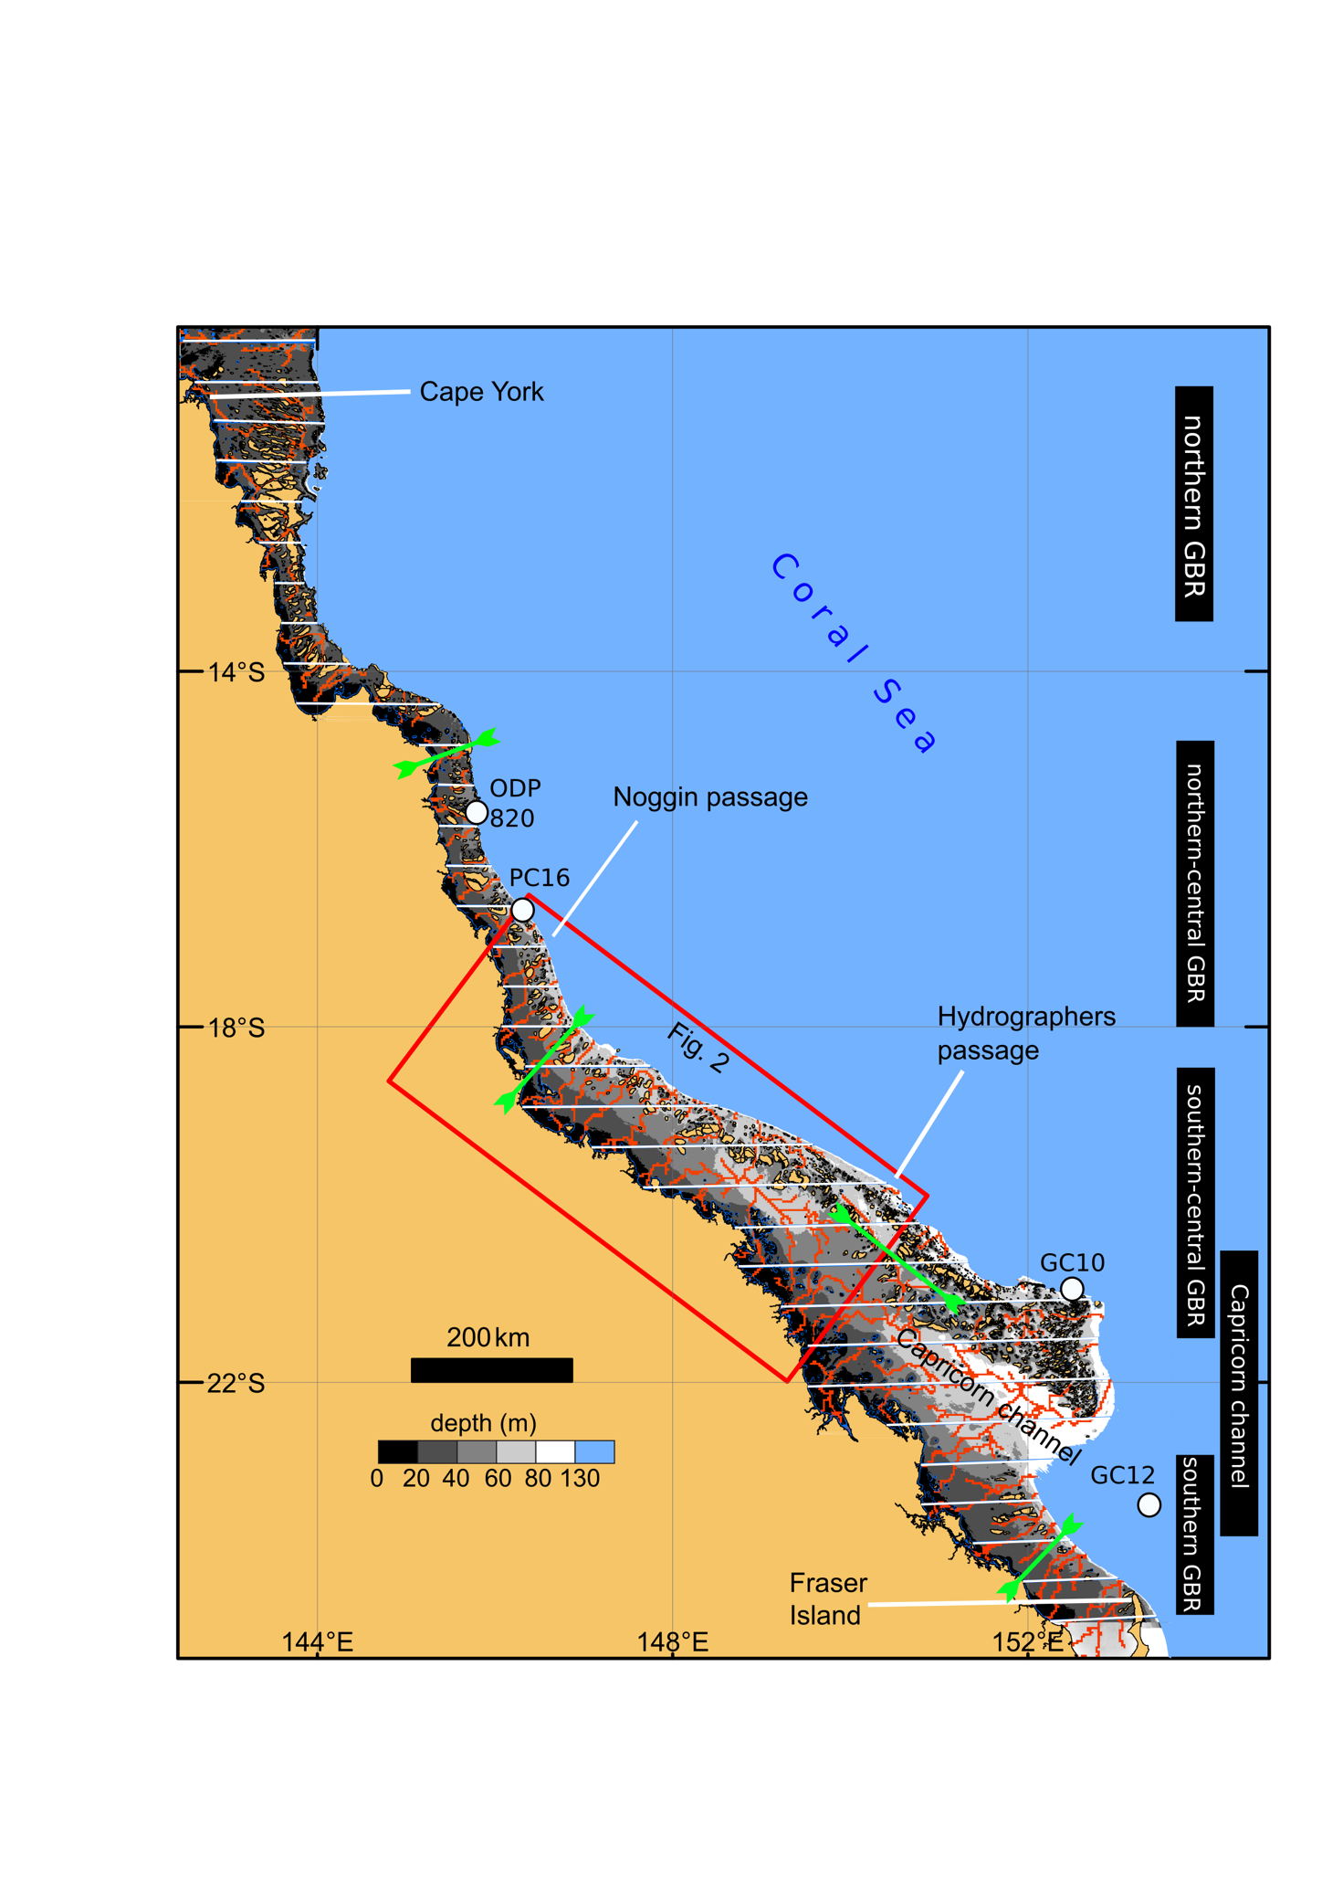

Figure . Location map highlighting: the bathymetry of the GBR shelf Beaman, 2010; the GBR sub-regions considered in this study (black boxes: northern, northern-central, southern-central, southern GBR and Capricorn Channel); the boundaries between each of the 33 latitudinal zones (white horizontal lines), the drainage network (brown lines) and the dominant drainage orientation for each region (green arrows).

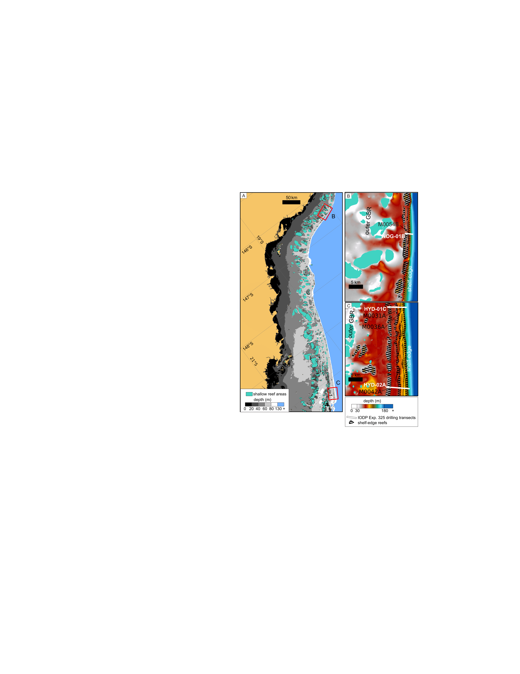

Figure . (A) Central GBR shelf displaying the bathymetry and two of the shelf margin study sites of the IODP Exp. 325, (B) Noggin Passage and (C) Hydrographers Passage, and the location of the IODP Exp. 325 drilling transects NOG-01B, HYD-01C, HYD-02A and some of the key boreholes in Webster et al., 2011. Notice the distance between the outer GBR shallow reefs and the shelf edge in each of the areas. The shallow reef areas derived from the submerged banks defined in Harris et al. (2012).

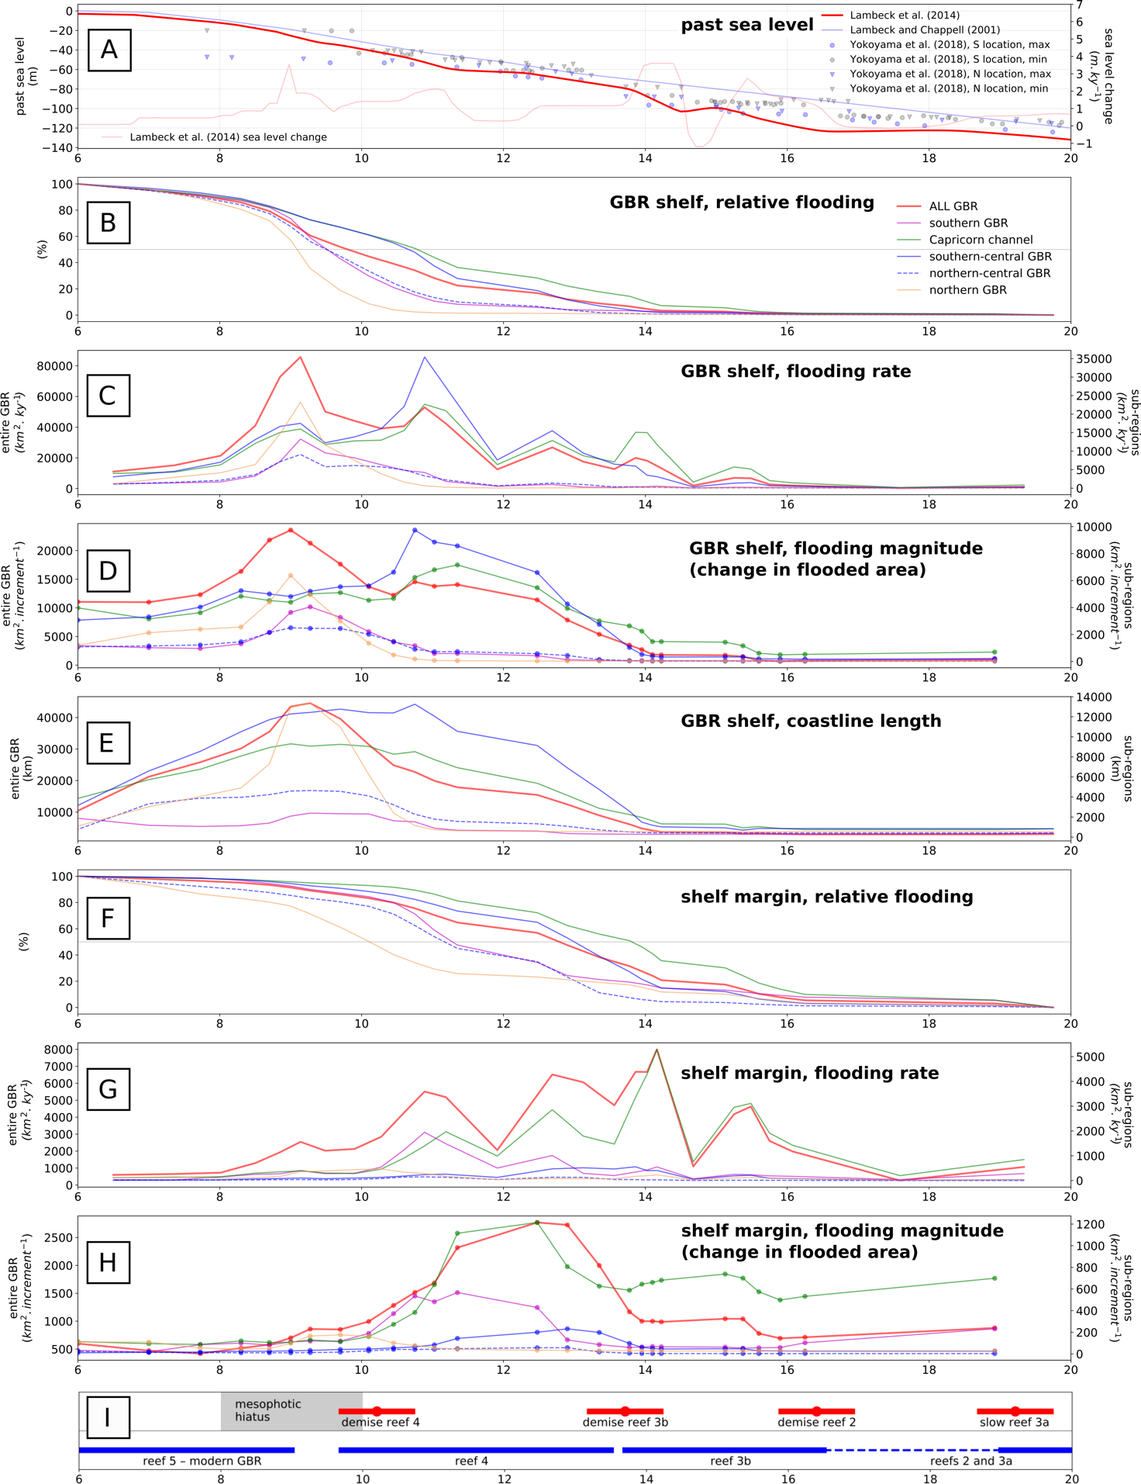

Figure . Marine flooding charts for the LGM and postglacial period: (A) sea-level curve and sea-level rate based on Lambeck et al. (2014), the dated palaeo-depth interpretations from Yokoyama et al. (2018) {Abbey, 2011 #1;Yokoyama, 2018 #133}have been added as a reference; (B) relative marine flooding for the entire GBR shelf and sub-regions; (C) flooding rate for the entire GBR and sub-regions; (D) flooding magnitude for the entire GBR shelf and sub-regions; (E) coastline length for the entire GBR shelf and sub-regions; (F) relative marine flooding for the shelf margin bathymetry subset and sub-regions; (G) flooding rate for the shelf margin bathymetry subset and sub-regions; (H) flooding magnitude for the shelf margin bathymetry subset and sub-regions; (I) depositional events in the shelf-edge reefs of the central GBR, modified from Abbey et al. (2013) and Webster et al. (2018).

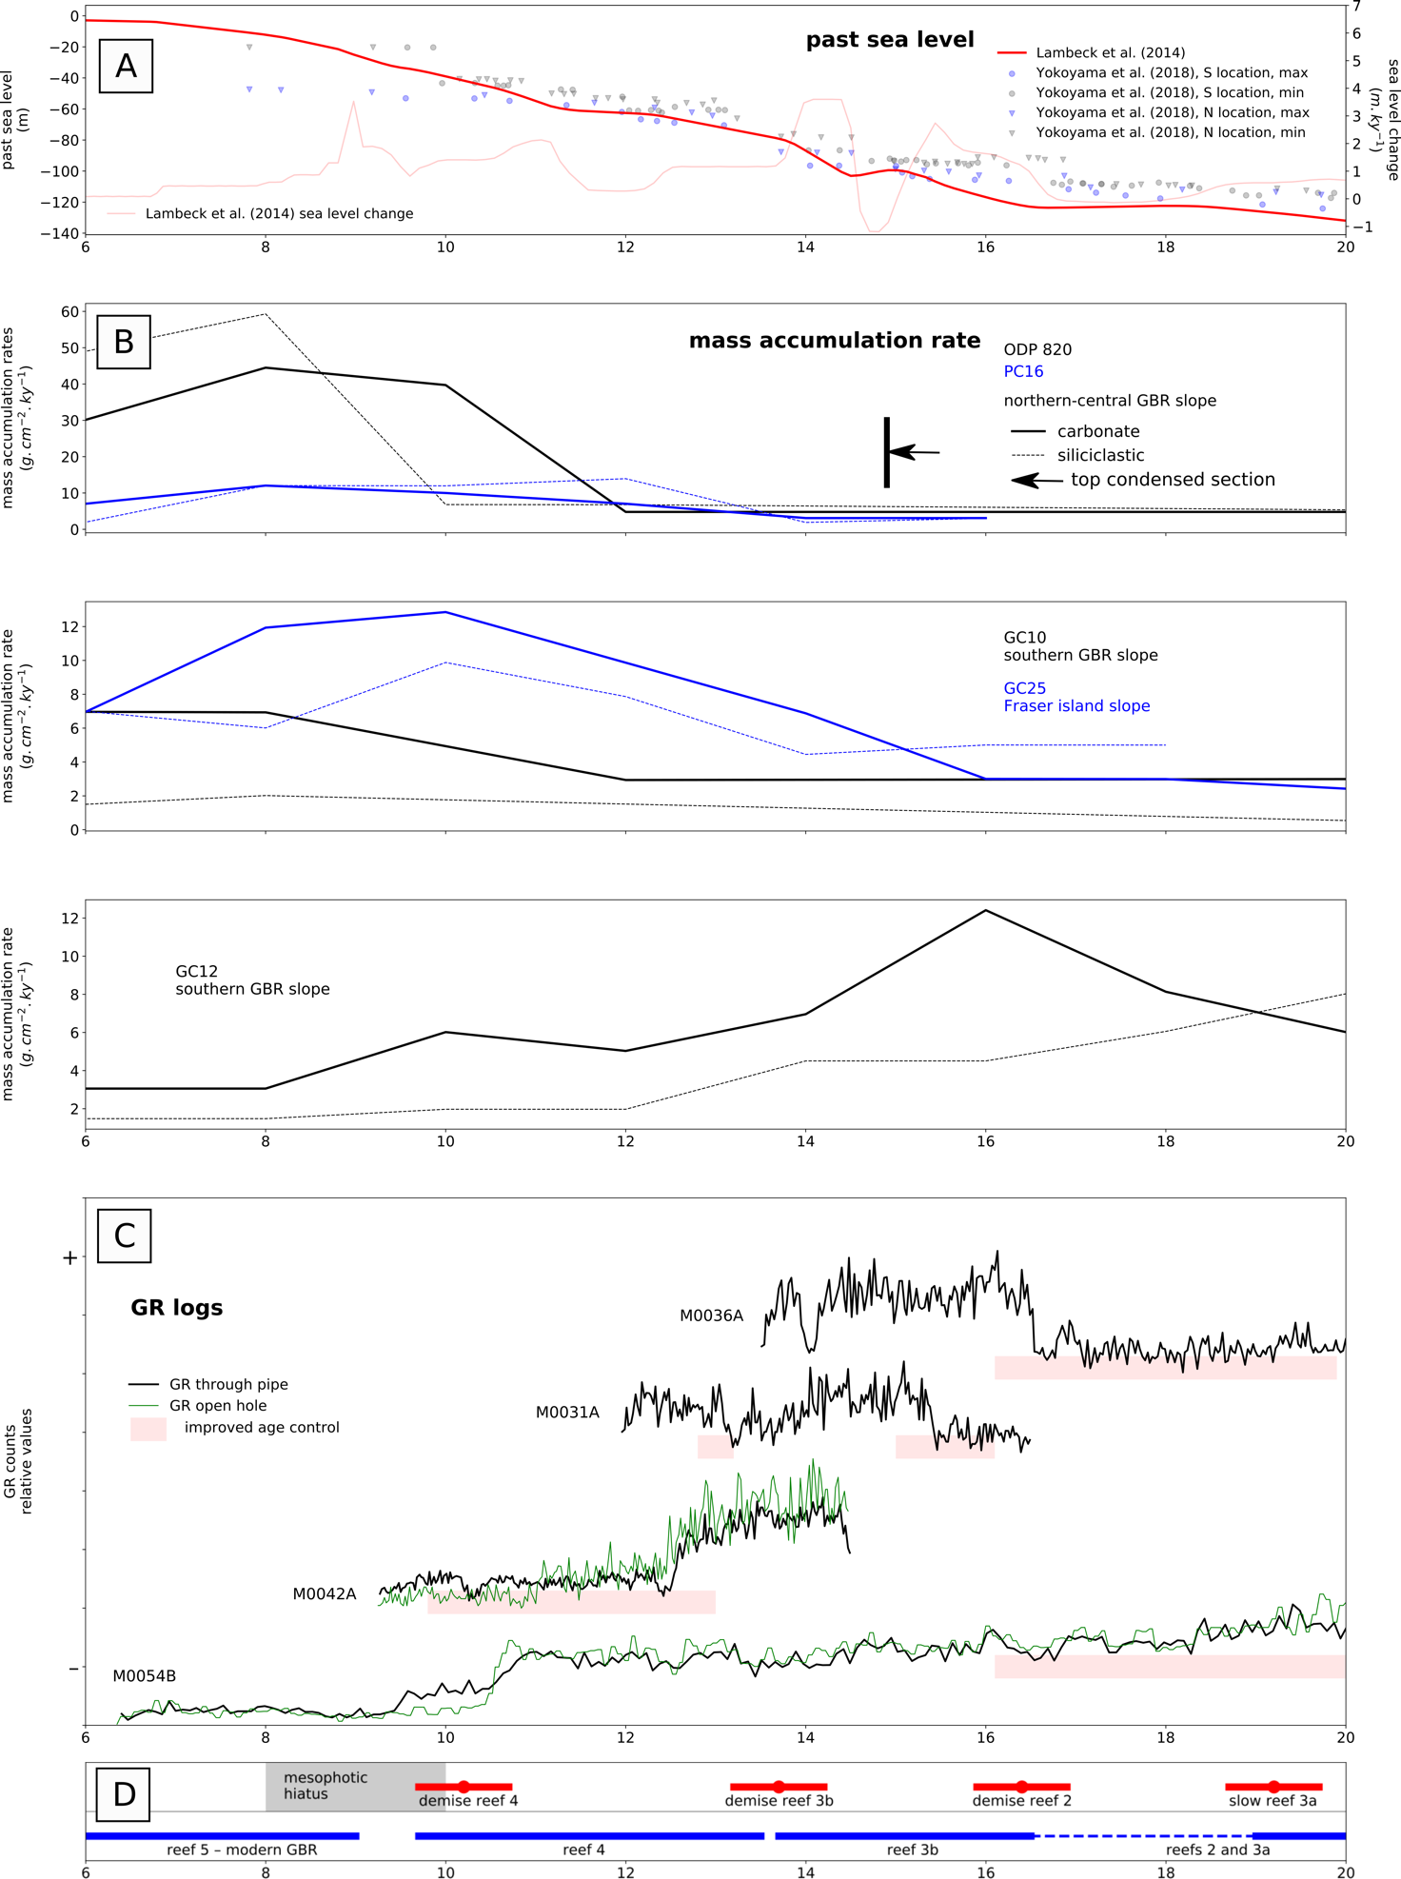

Figure 4. Core and borehole data and interpretations from the postglacial period: (A) sea-level curve and sea-level rate based on Lambeck et al. (2014), the dated palaeo-depth interpretations from Yokoyama et al. (2018) have been added as a reference; (B) mass accumulation rates in five locations of the continental slope, modified from Bostock et al. (2009) and Dunbar et al. (2000), in the light of recent pollen radiocarbon ages (Moss et al., 2017), the mass accumulation rates for hole ODP 820 –and possibly other slope cores– deserve revisiting particularly beyond 15 ka BP; (C) Gamma ray downhole logs in four locations of the IODP Exp. 325 (Webster et al., 2011) with intervals of improved chronological control highlighted, for borehole location see Figure 2; (D) depositional events in the shelf-edge reefs of the central GBR, modified from Abbey et al. (2013) and Webster et al. (2018).

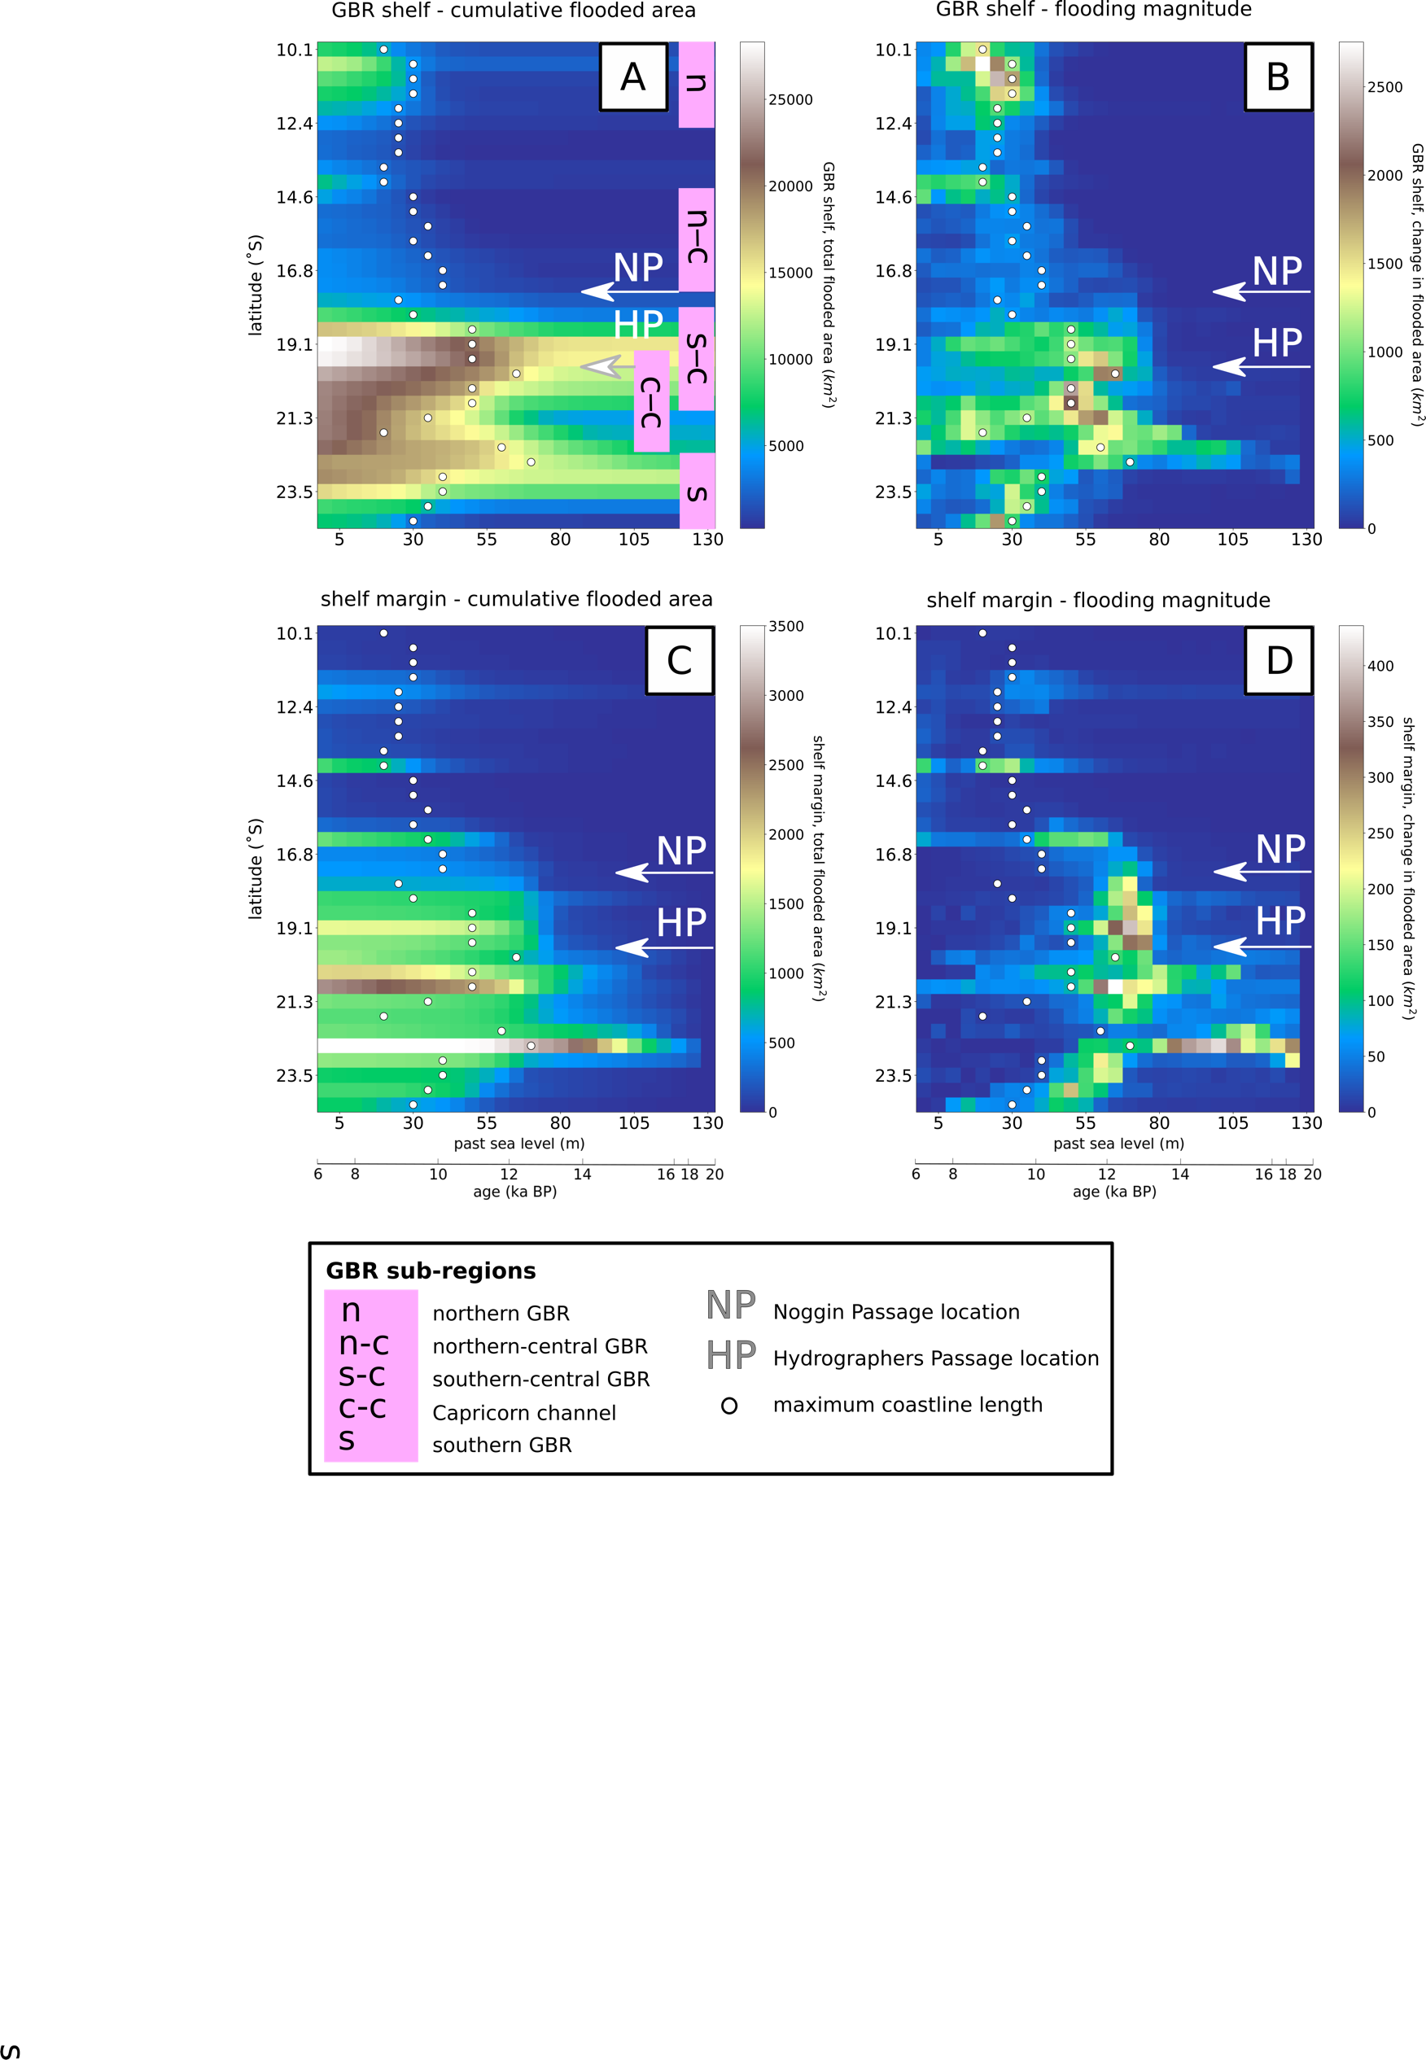

*Figure 5. Color maps based on past sea level, latitudinal location and flooding values. The color maps represent matrices containing the values of marine-flooded area, flooding magnitude and coastline length for each pair of past sea-level increment and latitudinal zones: (A) cumulative marine flooded area in the entire GBR shelf; (B) flooding magnitude in the entire GBR shelf; (C) cumulative marine flooded area in the shelf margin bathymetric subset; (D) flooding magnitude in the shelf margin bathymetric subset. Notice the locations of Noggin Passage (northern-central GBR) and Hydrographers Passage (southern-central GBR). Notice also the grouping of the GBR into sub-regions (in pink) for which flooding curves were produced (Figure 3).*

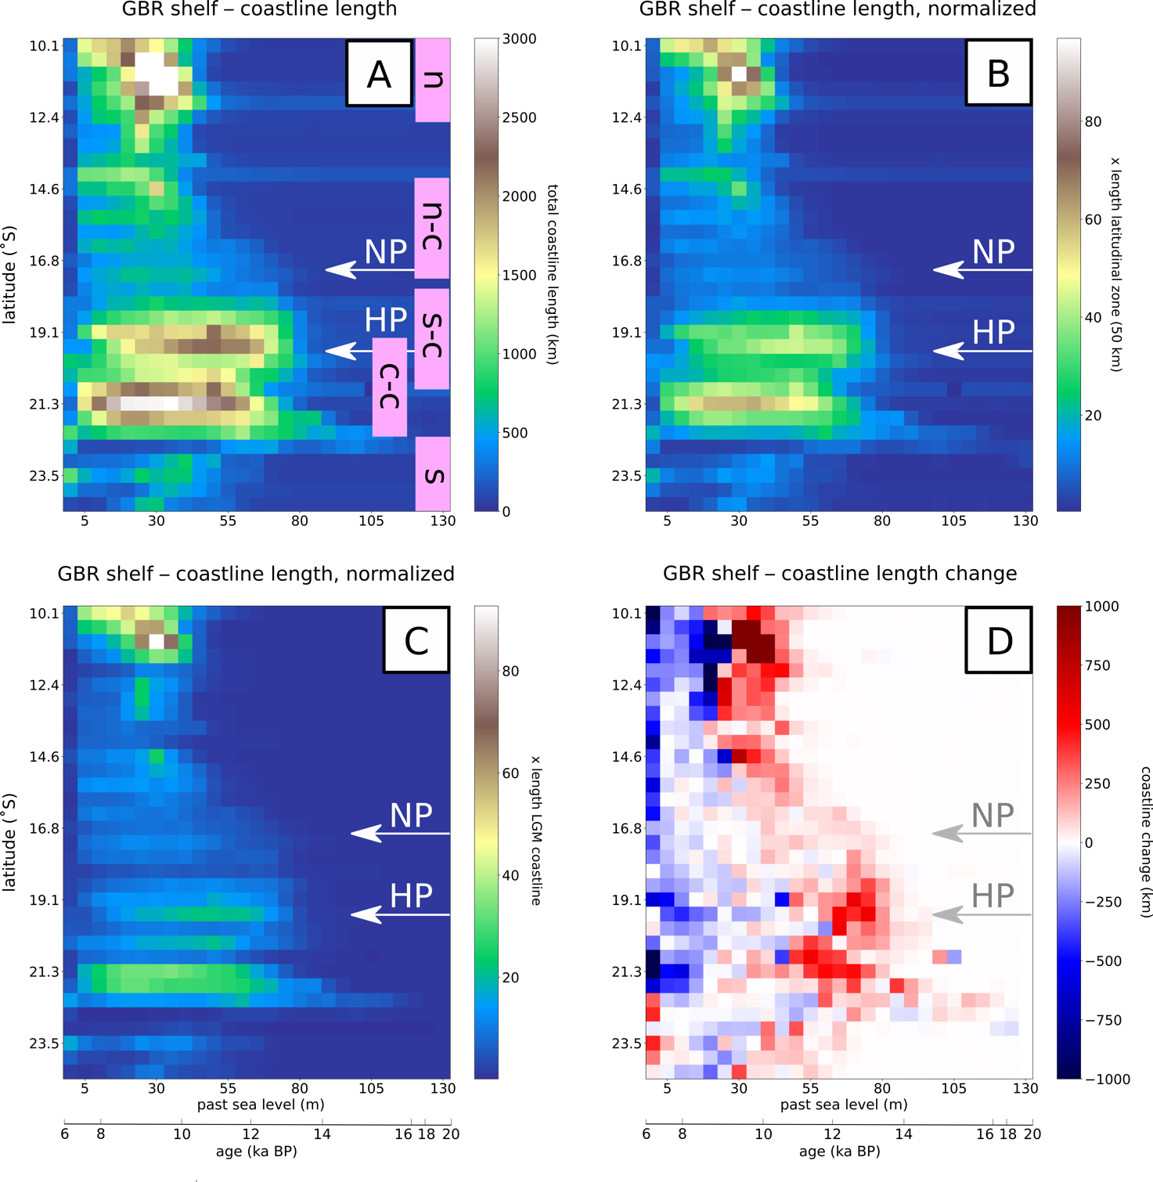

Figure . Color maps based on past sea level, latitudinal location and coastline length. The color maps represent matrices containing the values of marine-flooded area, flooding magnitude and coastline length for each pair of past sea-level increment and latitudinal zones: (A) coastline length evolution for the entire GBR shelf; (B) coastline length normalized to the 50 km width of each latitudinal zone; (C) coastline length normalized to LGM values; (D) coastline length variation for each successive sea-level increase, notice the period of major increase during the mid postglacial, which precedes a strong, late postglacial reduction in coastline length. The locations of Noggin Passage (northern-central GBR) and Hydrographers Passage (southern-central GBR) are highlighted. The grouping of the GBR into the zones (in pink) is the same as in figure 4, for which flooding curves were produced ().

# References

Abbey, E., Webster, J., Beaman, R.J., 2011. Geomorphology of submerged reefs on the shelf edge of the Great Barrier Reef: The influence of oscillating Pleistocene sea-levels. Marine Geology 288, 61-78.

Abbey, E., Webster, J.M., Braga, J.C., Jacobsen, G.E., Thorogood, G., Thomas, A.L., Camoin, G., Reimer, P.J., Potts, D.C., 2013. Deglacial mesophotic reef demise on the Great Barrier Reef. Palaeogeography Palaeoclimatology, Palaeoecology 392, 473-494.

Alongi, D.M., McKinnon, A.D., 2005. The cycling and fate of terrestrially-derived sediments and nutrients in the coastal zone of the Great Barrier Reef shelf. Marine Pollution Bulletin 51, 239-252.

Andersson, A.J., Mackenzie, F.T., 2004. Shallow-water oceans: a source or sink of atmospheric CO2? Frontiers in Ecology and the Environment 2, 348-353.

Andrews, J.C., Clegg, S., 1989. Coral Sea circulation and transport deduced from modal information models. Deep Sea Research Part A. Oceanographic Research Papers 36, 957-974.

Andrle, R., 1994. The angle measure technique: a new method for characterizing the complexity of geomorphic lines. Mathematical Geology 26, 83-97.

Bartley, J.D., Buddemeier, R.W., Bennett, D.A., 2001. Coastline complexity: a parameter for functional classification of coastal environments. Journal of Sea Research 46, 87-97.

Beaman, R.J., 2010. Project 3DGBR: A high-resolution depth model for the Great Barrier Reef and Coral Sea, Marine and Tropical Sciences Research Facility (MTSRF), Project 2.5i.1a Final Report, MTSRF, pp. 13 plus Appendix 1, Cairns, Australia.

Beaman, R.J., Webster, J.M., Wust, R.A.J., 2008. New evidence for drowned shelf edge reefs in the Great Barrier Reef, Australia. Marine Geology 247, 17-34.

Beaton, J.M., 1985. Evidence for a Coastal Occupation Time-Lag at Princess Charlotte Bay (North Queensland) and Implications for Coastal Colonization and Population Growth Theories for Aboriginal Australia. Archaeology in Oceania 20, 1-20.

Belperio, A., 1983. Terrigenous sedimentation in the central Great Barrier Reef lagoon: a model from the Burdekin region. BMR Journal of Australian Geology and Geophysics 8, 179-190.

Bongaerts, P., Riginos, C., Ridgway, T., Sampayo, E.M., van Oppen, M.J.H., Englebert, N., Vermeulen, F., Hoegh-Guldberg, O., 2010. Genetic Divergence across Habitats in the Widespread Coral Seriatopora hystrix and Its Associated Symbiodinium. PLoS ONE 5, e10871.

Bostock, H., Opdyke, B., Gagan, M., Kiss, A., Fifield, L.K., 2006. Glacial/interglacial changes in the East Australian current. Climate Dynamics 26, 645-659.

Bostock, H.C., Opdyke, B.N., Gagan, M.K., Fifield, L.K., 2009. Late Quaternary siliciclastic/carbonate sedimentation model for the Capricorn Channel, southern Great Barrier Reef province, Australia. Marine Geology 257, 107-123.

Bridge, T.C.L., Done, T.J., Beaman, R.J., Friedman, A., Williams, S.B., Pizarro, O., Webster, J.M., 2011. Topography, substratum and benthic macrofaunal relationships on a tropical mesophotic shelf margin, central Great Barrier Reef, Australia. Coral Reefs 30, 143-153.

Brinkman, R., Wolanski, E., Deleersnijder, E., McAllister, F., Skirving, W., 2002. Oceanic inflow from the Coral Sea into the Great Barrier Reef. Estuarine Coastal and Shelf Science 54, 655-668.

Brooke, B.P., Nichol, S.L., Huang, Z., Beaman, R.J., 2017. Palaeoshorelines on the Australian continental shelf: Morphology, sea-level relationship and applications to environmental management and archaeology. Continental Shelf Research 134, 26 - 38.

Chappell, J., Rhodes, E.G., Thom, B.G., Wallensky, E., 1982. Hydro-isostasy and the sea-level isobase of 5500 B.P. in north Queensland, Australia. Marine Geology 49, 81-90.

Chongprasith, P., 1992. Nutrient release and nitrogen transformations resulting from resuspension of Great Barrier Reef shelf sediments, PhD thesis, James Cook University of North Queensland.

Ciais, P., Sabine, C., Bala, G., Bopp, L., Brovkin, V., Canadell, J., Chhabra, A., DeFries, R., Galloway, J., Heimann, M., Jones, C., Le Quéré, C., Myneni, R.B., Piao, S., Thornton, P., 2013. Carbon and Other Biogeochemical Cycles, in: Stocker, T.F., Qin, D., Plattner, G.-K., Tignor, M., Allen, S.K., Boschung, J., Nauels, A., Xia, Y., Bex, V., Midgley, P.M. (Eds.), Climate Change 2013: The Physical Science Basis. Contribution of Working Group I to the Fifth Assessment Report of the Intergovernmental Panel on Climate Change. Cambridge University Press, Cambridge, United Kingdom and New York, NY, USA, pp. 465–570.

Clark, P.U., Dyke, A.S., Shakun, J.D., Carlson, A.E., Clark, J., Wohlfarth, B., Mitrovica, J.X., Hostetler, S.W., McCabe, A.M., 2009. The Last Glacial Maximum. Science 325, 710-714.

Cornell, H.V., Karlson, R.H., 2000. Coral species richness: ecological versus biogeographical influences. Coral Reefs 19, 37-49.

Croke, J., Jansen, J.D., Amos, K., Pietsch, T.J., 2011. A 100 ka record of fluvial activity in the Fitzroy River Basin, tropical northeastern Australia. Quaternary Science Reviews 30, 1681-1695.

Davies, P., McKenzie, J., 1993. Controls on the Pliocene-Pleistocene evolution of the northeastern Australian continental margin, Proceedings of the Ocean Drilling Program, Scientific Results. TX (Ocean Drilling Program) College Station, pp. 755-762.

Davies, P.J., 1988. Evolution of the Great Barrier Reef - Reductionist dream or expansionist vision, International Coral Reefs Symposium, pp. 9-17.

Davies, P.J., 1992. Origins of the Great Barrier Reef. Search 23, 193-196.

Davies, P.J., 2011. Great Barrier reef: origin, evolution, and modern development, Encyclopedia of Modern Coral Reefs. Springer, pp. 504-534.

Davies, P.J., Peerdeman, F.M., 1998. The origin of the Great Barrier Reef - the impact of leg 133 drilling. Special Publication of the International Association of Sedimentologists 25, 23-38.

Davies, P.J., Symonds, P.A., Feary, D.A., Pigram, C.J., 1989. The evolution of the carbonate platforms of northeast Australia.

Dechnik, B., Webster, J.M., Davies, P.J., Braga, J.-C., Reimer, P.J., 2015. Holocene “turn-on” and evolution of the Southern Great Barrier Reef: Revisiting reef cores from the Capricorn Bunker Group. Marine Geology 363, 174-190.

Devlin, M., Waterhouse, J., Taylor, J., Brodie, J.E., 2001. Flood plumes in the Great Barrier Reef: spatial and temporal patterns in composition and distribution. Great Barrier Reef Marine Park Authority.

DiCaprio, L., Müller, R.D., Gurnis, M., 2010. A dynamic process for drowning carbonate reefs on the northeastern Australian margin. Geology 38, 11-14.

Dunbar, G.B., Dickens, G.R., Carter, R.M., 2000. Sediment flux across the Great Barrier Reef Shelf to the Queensland Trough over the last 300 ky. Sedimentary Geology 133, 49-92.

Eyre, B., 1998. Transport, retention and transformation of material in Australian estuaries. Estuaries 21, 540-551.

Felis, T., McGregor, H.V., Linsley, B.K., Tudhope, A.W., Gagan, M.K., Suzuki, A., Inoue, M., Thomas, A.L., Esat, T.M., Thompson, W.G., Tiwari, M., Potts, D.C., Mudelsee, M., Yokoyama, Y., Webster, J.M., 2014. Intensification of the meridional temperature gradient in the Great Barrier Reef following the Last Glacial Maximum. Nature Communications 5, 1-7.

Fielding, C.R., Trueman, J.D., Dickens, G.R., Page, M., 2003. Anatomy of the buried Burdekin River channel across the Great Barrier Reef shelf: how does a major river operate on a tropical mixed siliciclastic/carbonate margin during sea level lowstand? Sedimentary Geology 157, 291-301.

Francis, J.M., Dunbar, G.B., Dickens, G.R., Sutherland, I.A., Droxler, A.W., 2007. Siliciclastic sediment across the north queensland margin (Australia): A Holocene perspective on reciprocal versus coeval deposition in tropical mixed siliciclastic-carbonate systems. Journal of Sedimentary Research 77, 572-586.

Furnas, M., 2003. Catchments and Corals: Terrestrial Runoff to the Great Barrier Reef. Australian Institute of Marine Science & CRC Reef Research Centre.

Gischler, E., Droxler, A., Thomas, A., Webster, J.M., Yokoyama, Y., Schoene, B., 2013. Microfacies and diagenesis of older Pleistocene (pre-last glacial maximum) reef deposits, Great Barrier Reef, Australia (IODP Expedition 325): A quantitative approach. Sedimentology 60, 1432-1466.

Grindrod, J., Moss, P., Van der Kaars, S., 1999. Late Quaternary cycles of mangrove development and decline on the north Australian continental shelf. Journal of Quaternary Science 14, 465-470.

Harper, B.B., Puga-Bernabéu, Á., Droxler, A.W., Webster, J.M., Gischler, E., Tiwari, M., Lado-Insua, T., Thomas, A.L., Morgan, S., Jovane, L., Röhl, U., 2015. Mixed Carbonate–Siliciclastic Sedimentation Along the Great Barrier Reef Upper Slope: A Challenge To the Reciprocal Sedimentation Model. Journal of Sedimentary Research 85, 1019-1036.

Harris, P.T., Bridge, T.C., Beaman, R.J., Webster, J.M., Nichol, S.L., Brooke, B.P., 2012. Submerged banks in the Great Barrier Reef, Australia, greatly increase available coral reef habitat. ICES Journal of Marine Science 70, 284-293.

Harris, P.T., Davies, P.J., Marshall, J.F., 1990. Late Quaternary sedimentation on the Great Barrier Reef continental shelf and slope east of Townsville, Australia. Marine Geology 94, 55-77.

Harris, P.T., Heap, A., Passlow, V., Hughes, M., Daniell, J., Hemer, M., Anderson, O., 2005. Tidally incised valleys on tropical carbonate shelves: An example from the northern Great Barrier Reef, Australia. Marine Geology 220, 181-204.

Harris, P.T., Heap, A.D., 2009. Cyclone-induced net sediment transport pathway on the continental shelf of tropical Australia inferred from reef talus deposits. Continental Shelf Research 29, 2011-2019.

Harrison, C.G.A., Miskell, K.J., Brass, G.W., Saltzman, E.S., Sloan, J.L., 1983. Continental hypsography. Tectonics 2, 357-377.

Heap, A.D., Dickens, G.R., Stewart, L.K., Woolfe, K.J., 2002. Holocene storage of siliciclastic sediment around islands on the middle shelf of the Great Barrier Reef Platform, north-east Australia. Sedimentology 49, 603-621.

Heap, A.D., Harris, P.T., Fountain, L., 2009. Neritic carbonate for six submerged coral reefs from northern Australia: Implications for Holocene global carbon dioxide. Palaeogeography Palaeoclimatology Palaeoecology 283, 77-90.

Heap, A.D., Larcombe, P., Woolfe, K.J., 1999. Storm-dominated sedimentation in a protected basin fringed by coral reefs, Nora Inlet, Whitsunday Islands, Great Barrier Reef, Australia. Australian Journal of Earth Sciences 46, 443-451.

Hinestrosa, G., Webster, J.M., Beaman, R.J., 2016. Postglacial sediment deposition along a mixed carbonate-siliciclastic margin: New constraints from the drowned shelf-edge reefs of the Great Barrier Reef Australia. Palaeogeography, Palaeoclimatology, Palaeoecology 446, 168-185.

Hinestrosa, G., Webster, J.M., Beaman, R.J., Anderson, L.M., 2014. Seismic stratigraphy and development of the shelf-edge reefs of the Great Barrier Reef Australia. Marine Geology 353, 1-20.

Hopley, D., 2006. Coral reef growth on the shelf margin of the Great Barrier Reef with special reference to the Pompey Complex. Journal of Coastal Research 22, 150-174.

Hopley, D., Smithers, S.G., Parnell, K., 2007. The geomorphology of the Great Barrier Reef, First edition ed. Cambridge University Press.

Humblet, M., Webster, J.M., 2017. Coral community changes in the Great Barrier Reef in response to major environmental changes over glacial-interglacial timescales. Palaeogeography, Palaeoclimatology, Palaeoecology 472, 216 - 235.

Johnson, D.P., Searle, D.E., 1984. Post-glacial seismic stratigraphy, Central Great Barrier Reef, Australia. Sedimentology 31, 335-352.

Johnson, D.P., Searle, D.E., Hopley, D., 1982. Positive relief over buried post-glacial channels, Great Barrier Reef province, Australia. Marine Geology 46, 149-159.

King, B., Wolanski, E., 1996. Tidal current variability in the Central Great Barrier Reef. Journal of Marine Systems 9, 187-202.

Kleypas, J.A., 1996. Coral reef development under naturally turbid conditions: fringing reefs near Broad Sound, Australia. Coral Reefs 15, 153-167.

Lambeck, A., Woolfe, K.J., 2000. Composition and textural variability along the 10m isobath, Great Barrier Reef: evidence for pervasive northward sediment transport. Australian Journal of Earth Sciences 47, 327-335.

Lambeck, K., Chappell, J., 2001. Sea level change through the last glacial cycle. Science 292, 679-686.

Lambeck, K., Nakada, M., 1990. Late Pleistocene and Holocene sea-level change along the Australian coast. Palaeogeography, Palaeoclimatology, Palaeoecology 89, 143-176.

Lambeck, K., Rouby, H., Purcell, A., Sun, Y., Sambridge, M., 2014. Sea level and global ice volumes from the Last Glacial Maximum to the Holocene. Proceedings of the National Academy of Sciences 111, 15296-15303.

Larcombe, P., Carter, R.M., 1998. Sequence architecture during the Holocene transgression: an example from the Great Barrier Reef shelf, Australia. Sedimentary Geology 117, 97-121.

Larcombe, P., Carter, R.M., 2004. Cyclone pumping, sediment partitioning and the development of the Great Barrier Reef shelf system: a review. Quaternary Science Reviews 23, 107-135.

Larcombe, P., Woolfe, K.J., 1999. Terrigenous sediments as influences upon Holocene nearshore coral reefs, central Great Barrier Reef, Australia. Australian Journal of Earth Sciences 46, 141-154.

Lawrence, K.T., Herbert, T.D., 2005. Late Quaternary sea-surface temperatures in the western Coral Sea: implications for the growth of the Australian Great Barrier Reef. Geology 33, 677-680.

Luick, J.L., Mason, L., Hardy, T., Furnas, M.J., 2007. Circulation in the Great Barrier Reef Lagoon using numerical tracers and in situ data. Continental Shelf Research 27, 757-778.

Mandelbrot, B.B., 1967. How long is the coast of Britain. Science 156, 636-638.

Maxwell, W.G.H., 1968. Atlas of the Great Barrier Reef. Elsevier Pub. Co.

Maxwell, W.H., Swinchatt, J.P., 1970. Great Barrier Reef: regional variation in a terrigenous-carbonate province. Geological Society of America Bulletin 81, 691-724.

Meade, R.H., 1982. Sources, sinks, and storage of river sediment in the Atlantic drainage of the United States. Journal of Geology 90, 235-252.

Miall, A.D., 1991. Stratigraphic sequences and their chronostratigraphic correlation. Journal of Sedimentary Research 61, 497-505.

Mitchum, R.M., Vail, P.R., Todd, R.G., 1976. Regional seismic interpretation using sequences and eustatic cycles. AAPG Bulletin-American Association of Petroleum Geologists 60, 699-699.

Montaggioni, L.F., 2005. History of Indo-Pacific coral reef systems since the last glaciation: development patterns and controlling factors. Earth-Science Reviews 71, 1-75.

Moss, P.T., Dunbar, G.B., Thomas, Z., Turney, C., Kershaw, A.P., Jacobsen, G.E., 2017. A 60 000‐year record of environmental change for the Wet Tropics of north‐eastern Australia based on the ODP 820 marine core. Journal of Quaternary Science 32, 704-716.

Moss, P.T., Kershaw, A.P., Grindrod, J., 2005. Pollen transport and deposition in riverine and marine environments within the humid tropics of northeastern Australia. Review of Palaeobotany and Palynology 134, 55-69.

Moss, P.T., Kershaw, P.A., 2000. The last glacial cycle from the humid tropics of northeastern Australia: comparison of a terrestrial and a marine record. Palaeogeography, Palaeoclimatology, Palaeoecology 155, 155-176.

Mount, J.F., 1984. Mixing of siliciclastic and carbonate sediments in shallow shelf environments. Geology 12, 432-435.

Mulvaney, D.J., 1975. Prehistory of Australia. Penguin Books, Ringwood, Victoria and Harmondsworth, England.

Mulvaney, D.J., Kamminga, J., Mulvaney, D.J., 1999. The prehistory of Australia. Smithsonian Institution Press Washington, DC.

Neumann, A.C., Macintyre, I.G., 1985. Reef Response of Sea Level Rise: Keep-Up, Catch-Up, or Give-up, in: Gabrie, C., Toffart, J.L., Salvat, B. (Eds.), Fifth International Coral Reef Congress Volume 3, pp. 105-110.

Nunn, P.D., Reid, N.J., 2016. Aboriginal Memories of Inundation of the Australian Coast Dating from More than 7000 Years Ago. Australian Geographer 47, 11-47.

Page, M.C., Dickens, G.R., 2005. Sediment fluxes to Marion Plateau (southern Great Barrier Reef province) over the last 130 ky: New constraints on ‘transgressive-shedding’ off northeastern Australia. Marine Geology 219, 27-45.

Patterson, W., Walter, L.M., 1994. Depletion of 13C in seawater SC02 on modern carbonate platforms: Significance for the carbon isotopic record of carbonates. Geology 22, 885-888.

Peerdeman, F.M., Davies, P.J., Chivas, A., 1993. Pleistocene sea-level and climate change along the margin of northeast Australia, Proceedings Ocean Drilling Program 133, Scientific Results.

Petherick, L., Bostock, H., Cohen, T.J., Fitzsimmons, K., Tibby, J., Fletcher, M.-S., Moss, P., Reeves, J., Mooney, S., Barrows, T., 2013. Climatic records over the past 30 ka from temperate Australia–a synthesis from the Oz-INTIMATE workgroup. Quaternary Science Reviews 74, 58-77.

Porter-Smith, R., Lyne, V.D., Kloser, R.J., Lucieer, V.L., 2012. Catchment-based classification of Australia's continental slope canyons. Marine Geology 303-306, 183-192.

Porter-Smith, R., McKinlay, J., 2012. Mesoscale coastal complexity and its relationship to structure and forcing from marine processes. Marine Geology 323-325, 1-13.

Puga-Bernabéu, Á., Webster, J.M., Beaman, R.J., Guilbaud, V., 2011. Morphology and controls on the evolution of a mixed carbonate–siliciclastic submarine canyon system, Great Barrier Reef margin, north-eastern Australia. Marine Geology 289, 100-116.

Puga-Bernabéu, Á., Webster, J.M., Beaman, R.J., Guilbaud, V., 2013. Variation in canyon morphology on the Great Barrier Reef margin, north-eastern Australia: the influence of slope and barrier reefs. Geomorphology 191, 35-50.

Puga-Bernabéu, Á., Webster, J.M., Beaman, R.J., Reimer, P.J., Renema, W., 2014. Filling the gap: A 60 ky record of mixed carbonate-siliciclastic turbidite deposition from the Great Barrier Reef. Marine and Petroleum Geology 50, 40-50.

Rees, S.A., Opdyke, B.N., Wilson, P.A., Henstock, T.J., 2007. Significance of Halimeda bioherms to the global carbonate budget based on a geological sediment budget for the Northern Great Barrier Reef, Australia. Coral Reefs 26, 177-188.

Reeves, J.M., Bostock, H.C., Ayliffe, L.K., Barrows, T.T., De Deckker, P., Devriendt, L.S., Dunbar, G.B., Drysdale, R.N., Fitzsimmons, K.E., Gagan, M.K., 2013. Palaeoenvironmental change in tropical Australasia over the last 30,000 years -a synthesis by the OZ-INTIMATE group. Quaternary Science Reviews 74, 97-114.

Renema, W., Beaman, R.J., Webster, J.M., 2013. Mixing of relict and modern tests of Larger Benthic Foraminifera on the Great Barrier Reef shelf margin. Marine Micropaleontology 101, 68-75.

Ridgway, K.R., Dunn, J.R., 2003. Mesoscale structure of the mean East Australian Current System and its relationship with topography. Progress in Oceanography 56, 189-222.

Ryan, D.A., Bostock, H.C., Brooke, B.P., Marshall, J.F., 2007. Bathymetric expression of the Fitzroy River palaeochannel, northeast Australia: Response of a major river to sea-level change on a semi-rimmed, mixed siliciclastic-carbonate shelf. Sedimentary Geology 201, 196-211.

Scoffin, T.P., Tudhope, A.W., 1985. Sedimentary environments of the central region of the Great Barrier Reef of Australia. Coral Reefs 4, 81-93.

Searle, D.E., Harvey, N., 1982. Interpretation of inter-reefal seismic data - A case-study from Michaelmas reef, Australia. Marine Geology 46, M9-M16.

Tachikawa, K., Vidal, L., Sonzogni, C., Bard, E., 2009. Glacial/interglacial sea surface temperature changes in the Southwest Pacific ocean over the past 360 ka. Quaternary Science Reviews 28, 1160-1170.

Troedson, A.L., Davies, P.J., 2001. Contrasting facies patterns in subtropical and temperate continental slope sediments: inferences from east Australian late Quaternary records. Marine Geology 172, 265-285.

Ulm, S., 2011. Coastal foragers on southern shores: Marine resource use in northeast Australia since the late Pleistocene, Trekking the Shore. Springer, pp. 441-461.

Uthicke, S., Nobes, K., 2008. Benthic Foraminifera as ecological indicators for water quality on the Great Barrier Reef. Estuarine Coastal and Shelf Science 78, 763-773.

Vail, P.R., Mitchum, R.M., Thompson, S., 1977. Seismic stratigraphy and global changes of sea level, Part 4: Global cycles of relative change of sea level. AAPG American Association of Petroleum Geologists, Memoir 26, 83 97.

Van Heijst, M.W.I.M., Postma, G., 2001. Fluvial response to sea-level changes: a quantitative analogue, experimental approach. Basin Research 13, 269-292.

Van Wagoner, J.C., Posamentier, H.W., Mitchum, R.M., Vail, P.R., Sarg, J.F., Loutit, T.S., Hardenbol, J., 1988. An overview of sequence stratigraphy and key definitions, in: Wilgus, C.K., Hastings, B.S., Kendall, C.G.S.C., Posamentier, H.W., Ross, C.A., Van Wagoner, J.C. (Eds.), Sea Level Changes -An Integrated Approach.

Webster, J.M., Braga, J.C., Humblet, M., Potts, D.C., Iryu, Y., Yokoyama, Y., Fujita, K., Bourillot, R., Esat, T.M., Fallon, S., 2018. Response of the Great Barrier Reef to sea-level and environmental changes over the past 30,000 years. Nature Geoscience, 1.

Webster, J.M., Davies, P.J., 2003. Coral variation in two deep drill cores: significance for the Pleistocene development of the Great Barrier Reef. Sedimentary Geology 159, 61-80.

Webster, J.M., Yokoyama, Y., Cotterill, C., Scientists, E., 2011. Proceedings of the Integrated Ocean Drilling Program, Expedition 325: Great Barrier Reef Environmental Changes.

Williams, A.N., Ulm, S., Sapienza, T., Lewis, S., Turney, C.S.M., 2018. Sea-level change and demography during the last glacial termination and early Holocene across the Australian continent. Quaternary Science Reviews 182, 144-154.

Wolanski, E., 1992. Hydrodynamics of mangrove swamps and their coastal waters. Hydrobiologia 247, 141-161.

Wolanski, E., 1994. Physical oceanographic processes of the Great Barrier Reef. CRC Press Inc., London.

Wolanski, E., Drew, E., Abel, K.M., Obrien, J., 1988. Tidal jets, nutrient upwelling and their influence in the productivity of the alga Halimeda in the Ribbon reefs, Great Barrier Reef. Estuarine Coastal and Shelf Science 26, 169-201.

Wolanski, E., Spagnol, S., 2000. Pollution by mud of Great Barrier Reef coastal waters. Journal of Coastal Research, 1151-1156.

Woodroffe, C.D., Webster, J.M., 2014. Coral reefs and sea-level change. Marine Geology 352, 248-267.

Woolfe, K.J., Larcombe, P., 1998. Terrigenous sediment accumulation as a regional control on the distribution of reef carbonates. Special Publication of the International Association of Sedimentologists 25, 295-310.

Woolfe, K.J., Larcombe, P., Naish, T., Purdon, R.G., 1998a. Lowstand rivers need not incise the shelf: An example from the Great Barrier Reef, Australia, with implications for sequence stratigraphic models. Geology 26, 75-78.

Woolfe, K.J., Larcombe, P., Orpin, A.R., Purdon, R.G., Michaelsen, P., McIntyre, C.M., Amjad, N., 1998b. Controls upon inner-shelf sedimentation, Cape York Peninsula, in the region of 12 degrees S. Australian Journal of Earth Sciences 45, 611-621.

Yokoyama, Y., Esat, T.M., Thompson, W.G., Thomas, A.L., Webster, J.M., Miyairi, Y., Sawada, C., Aze, T., Matsuzaki, H., Okuno, J.i., 2018. Rapid glaciation and a two-step sea level plunge into the Last Glacial Maximum. Nature 559, 603.

Yokoyama, Y., Purcell, A., Marshall, J.F., Lambeck, K., 2006. Sea-level during the early deglaciation period in the Great Barrier Reef, Australia. Global and Planetary Change 53, 147-153.

# Project data

Data provided with this paper:

* Spreadsheet with values for marine flooded area, flooding magnitude, flooding rate and coastline length, for each sea-level increment and latitudinal zone (*GBR_flooding_summary_35_latitudinal_zones.xlsx*)
* Spreadsheet with values for marine flooded area, flooding magnitude, flooding rate and coastline length, for grouped by sub-region (*GBR_flooding_summary_by_sub-region.xlsx*).
* Text files with flooding values for the GBR shelf, using original bathymetric model as per Beaman (2010) (*Flooded_area_GBR_dem_base-case.csv*); and using a version of the model lowered by 10 m (*Flooded_area_GBR_dem_minus-10m.csv*).
* Spreadsheet with age control for shelf-edge boreholes shown in Figure 2 and some plots (*Age_control_cores_GR.xlsx*). Data extracted from Felis et al. (2014) and Webster et al. (2011) and used to link the boreholes and Gamma ray logs to the flooding curves.

# Supplementary material

* Supplement 2. Depositional summary table.

|  |  |  |  |  |  |  |  |  |  |  |  |  |  |  |  |  |  |  |  |  |
| --- | --- | --- | --- | --- | --- | --- | --- | --- | --- | --- | --- | --- | --- | --- | --- | --- | --- | --- | --- | --- |
|  |  |  |  |  |  |  |  |  |  |  |  |  |  |  |  |  |  |  |  |  |
|  |  |  |  |  |  |  |  |  |  |  |  |  |  |  |  |  |  |  |  |  |
| **depositional event** | | **age**  **(ka BP)** | **MAR** | | | **relative flooding (%)** | | | | | | **flooding rate (relative)** | | | | | | **coastal complexity** | | |
|  |  |  | **(relative)** | | | **entire GBR** | | | **shelf-edge** | | | **entire GBR** | | | **shelf-edge** | | | **(relative)** | | |
|  | |  | **low** | **mid** | **high** | **0-30** | **31–60** | **>61** | **0-30** | **31–60** | **>61** | **low** | **mid** | **high** | **low** | **mid** | **high** | **low** | **mid** | **high** |
|  |  |  |  |  |  |  |  |  |  |  |  |  |  |  |  |  |  |  |  |  |
| ***shelf-edge mesophotic hiatus*** | |  |  |  |  |  |  |  |  |  |  |  |  |  |  |  |  |  |  |  |
| southern central GBR | | 8–10 |  |  | x |  |  | x |  |  | x |  | x |  |  | x |  |  |  | x |
|  |  |  |  |  |  |  |  |  |  |  |  |  |  |  |  |  |  |  |  |  |
| ***condensed section*** | |  |  |  |  |  |  |  |  |  |  |  |  |  |  |  |  |  |  |  |
| northern central GBR | | pre 15 |  |  |  | x |  |  | x |  |  | x |  |  | x |  |  | x |  |  |
| southern central GBR | |  |  |  |  |  |  |  |  |  |  |  |  |  |  |  |  |  |  |  |
| southern GBR - distal Capricorn Channel | | post 6.5 |  |  |  |  |  | x |  |  | x | x |  |  | x |  |  | x |  |  |
|  |  |  |  |  |  |  |  |  |  |  |  |  |  |  |  |  |  |  |  |  |
| ***offshore flux initiation*** | |  |  |  |  |  |  |  |  |  |  |  |  |  |  |  |  |  |  |  |
| northern central GBR | | 12–14 |  |  |  | x |  |  |  | x |  |  | x |  |  |  | x |  | x |  |
| southern central GBR | | 12 |  |  |  |  | x |  |  |  | x |  |  | x |  | x |  |  |  | x |
| southern GBR - distal Capricorn Channel | | pre 20 |  |  |  | ? |  |  | ? |  |  | ? |  |  | ? |  |  | ? |  |  |
|  |  |  |  |  |  |  |  |  |  |  |  |  |  |  |  |  |  |  |  |  |
| ***maximum siliciclastic flux*** | |  |  |  |  |  |  |  |  |  |  |  |  |  |  |  |  |  |  |  |
| northern central GBR | | 10–12 |  |  |  |  | x |  |  |  | x |  |  | x |  | x |  |  |  | x |
| southern central GBR | | 8 |  |  |  |  |  | x |  |  | x |  | x |  | x |  |  |  | x |  |
| southern GBR - distal Capricorn Channel | | 16 |  |  |  | x |  |  |  | x |  | x |  |  |  |  | ? | x |  |  |
|  |  |  |  |  |  |  |  |  |  |  |  |  |  |  |  |  |  |  |  |  |
| ***maximum carbonate flux*** | |  |  |  |  |  |  |  |  |  |  |  |  |  |  |  |  |  |  |  |
| northern central GBR | | 8 |  |  |  |  |  | x |  |  | x |  | x |  | x |  |  |  |  | x |
| southern central GBR | | 8 |  |  |  |  |  | x |  |  | x |  | x |  | x |  |  |  | x |  |
| southern GBR - distal Capricorn Channel | | 16 |  |  |  | x |  |  |  | x |  | x |  |  |  |  | ? | x |  |  |
|  |  |  |  |  |  |  |  |  |  |  |  |  |  |  |  |  |  |  |  |  |
|  |  |  | x | event occurrence and observed value | | | | |  |  |  |  |  |  |  |  |  |  |  |  |
|  |  |  |  | no data or not relevant | | |  |  |  |  |  |  |  |  |  |  |  |  |  |  |

Supplement Table summarising the main depositional events discussed in this study and their match with the flooding parameters.

* Supplement 2. Video in .mov format showing a flythrough over the Great Barrier Reef, displaying the bathymetric dataset used in this study. Same video can be seen at this web address: <https://youtu.be/BOvrNXGJhTA>

The file of this video is released under the Creative Commons Attribution 4.0 International Licence, © [www.deepreef.org](http://www.deepreef.org)

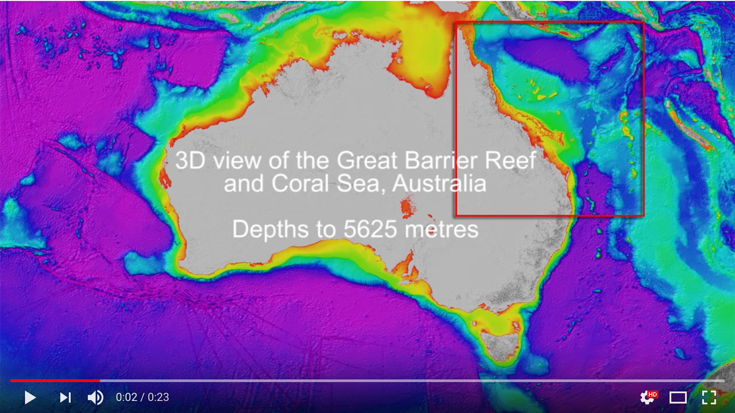

Supplement . Screenshot of the initial image of the video provided, © www.deepreef.org.